## Appendix C: Interface Design

In this part, I have design user interface for the user of this system. Before start interface design, I have to select the user for those I will make it. I already have found three type of user who will interact with this interface. They are

* **Admin:** They will be the university staff and have full access on the system. After login as an admin, he or she can see all information of the system. This information will show on admin dashboard. Admin can add new user in the system, change password, add various staff in different role and can control all the event of the system.
* **Teacher:** Teacher is also university staff and secondary user of the system. On teacher dashboard there will show all role base necessary report, event CMR statistical report. Teacher can see his or her own profile also. There has password changing and lock screen option for the teacher in this system.
* **Guest:** These users are also university staff. All teachers in a faculty will login the system as a guest. They can see only information. They will not able to write or erase anything in the system.

I have completed my full site design through three processes, which are low fidelity prototype or sketching, high fidelity prototype or wire framing and outcome of the system.

**Low fidelity prototype (Sketching):** In this part, I am giving the primary design that I have made for making the original site.

Login Page

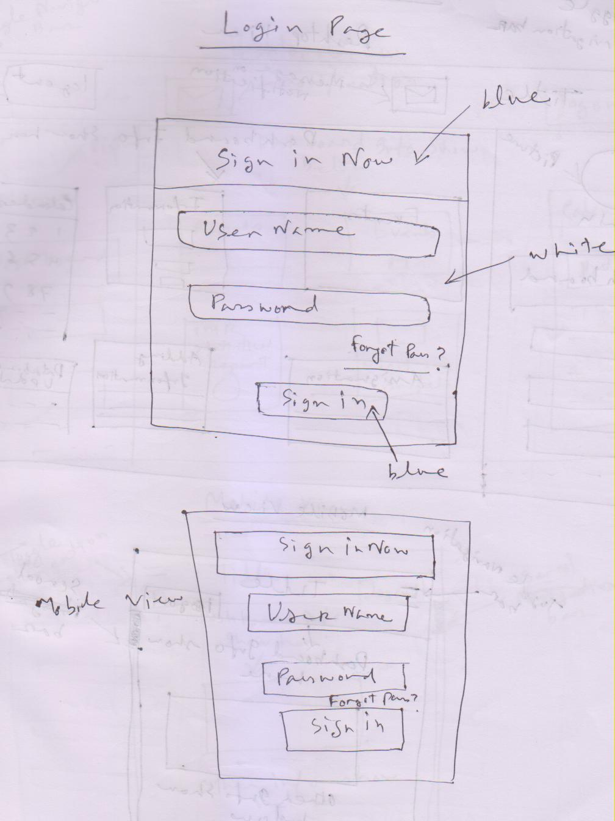

**Fig S.1:** Sketch for login page in mobile view and desktop view.

Admin Home Page

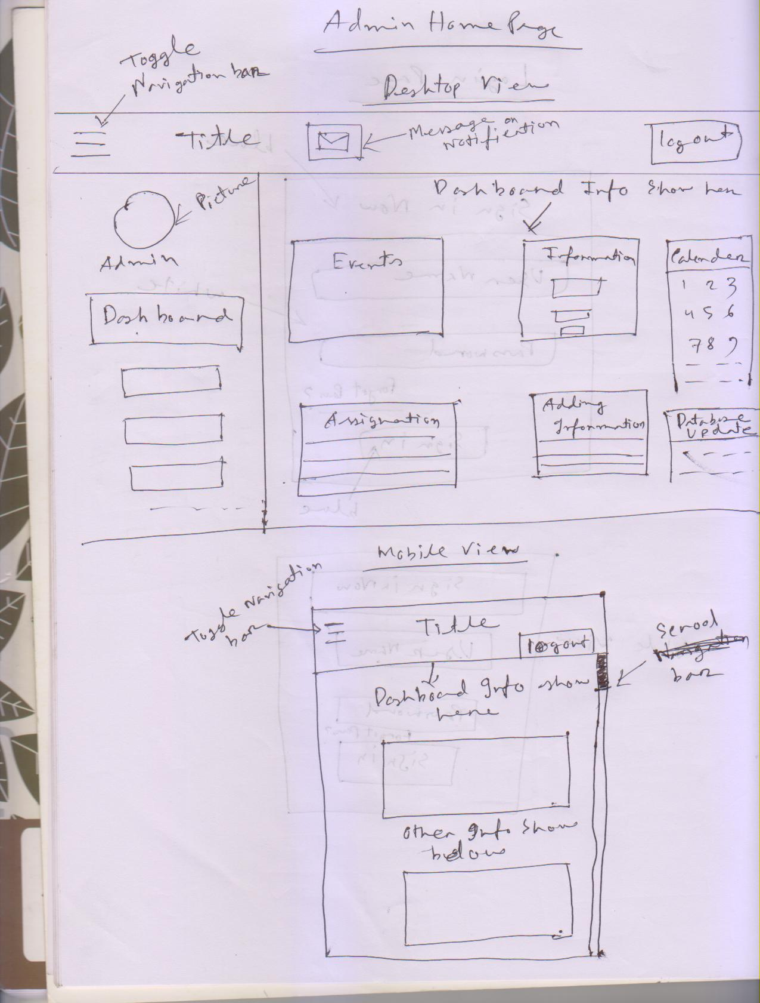

**Fig S.2:** Sketch for Admin Home page in mobile view and desktop view.

Teacher Home Page

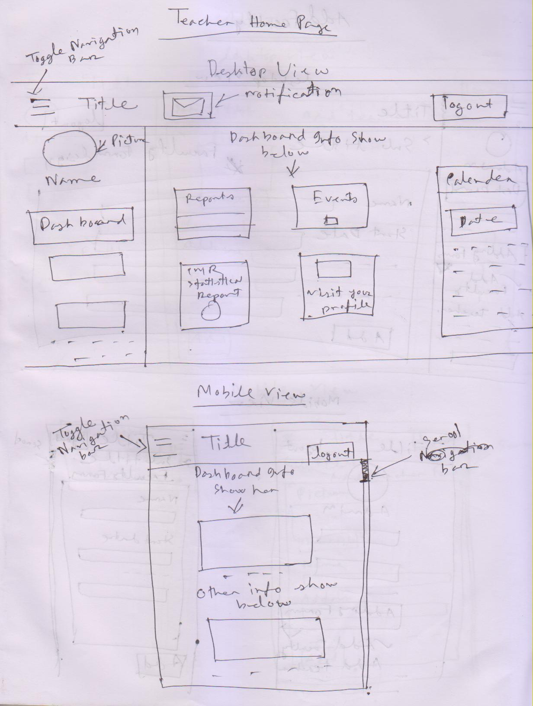

**Fig S.3:** Sketch for Teacher Home page in mobile view and desktop view.

Add Faculty

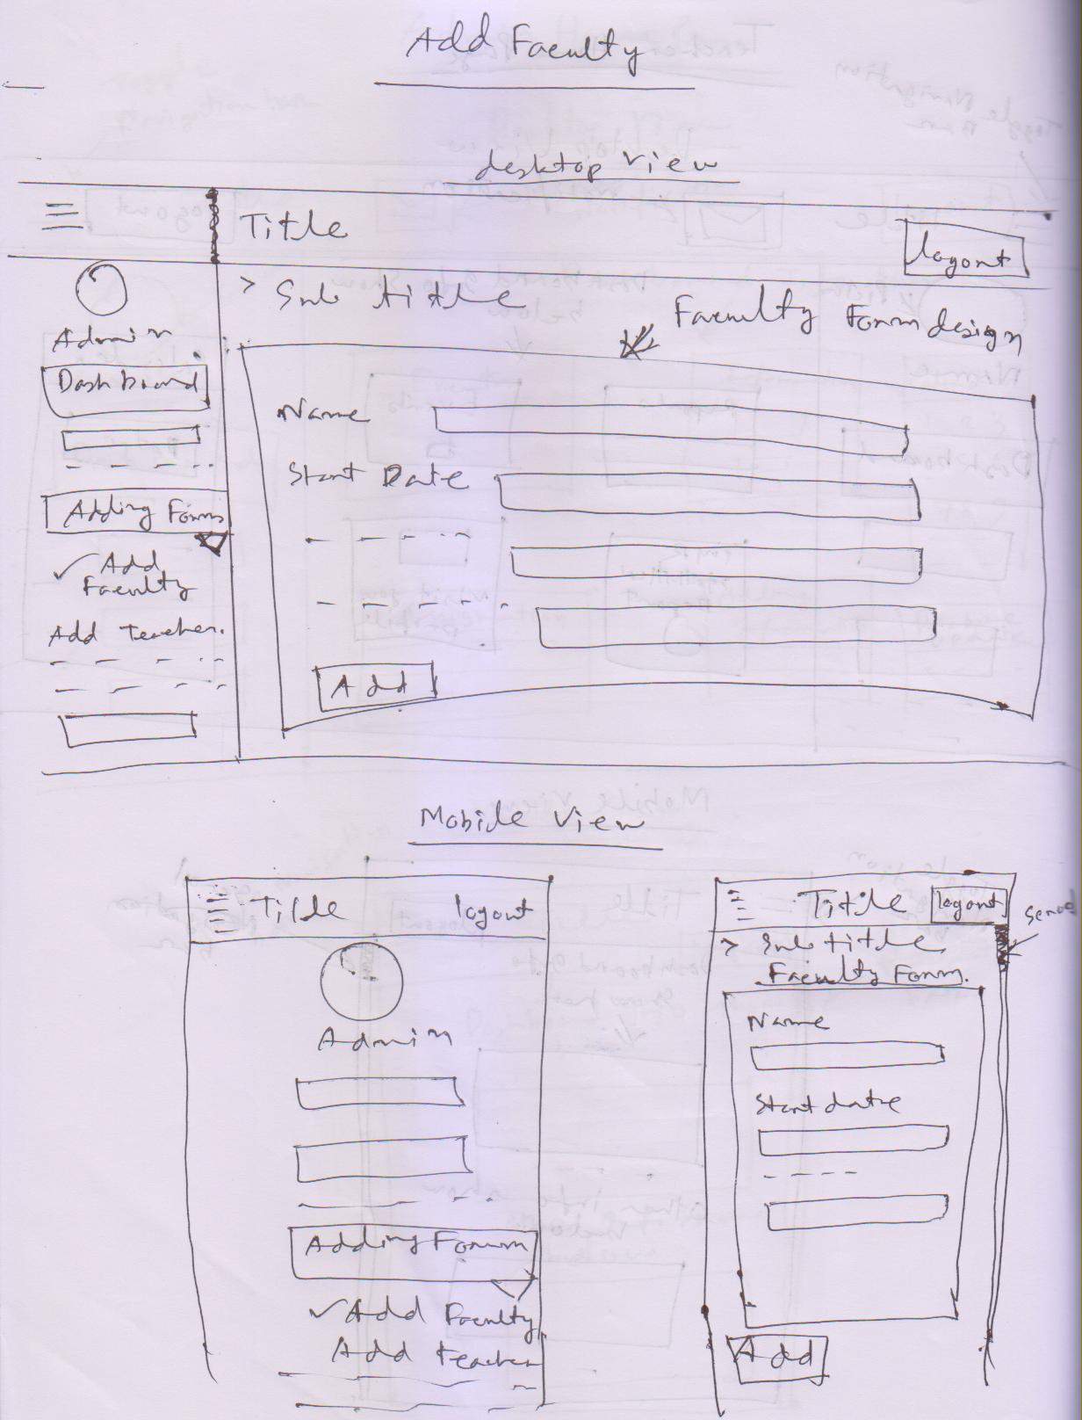

**Fig S.4:** Sketch for Add faculty page in mobile view and desktop view.

Add Teacher

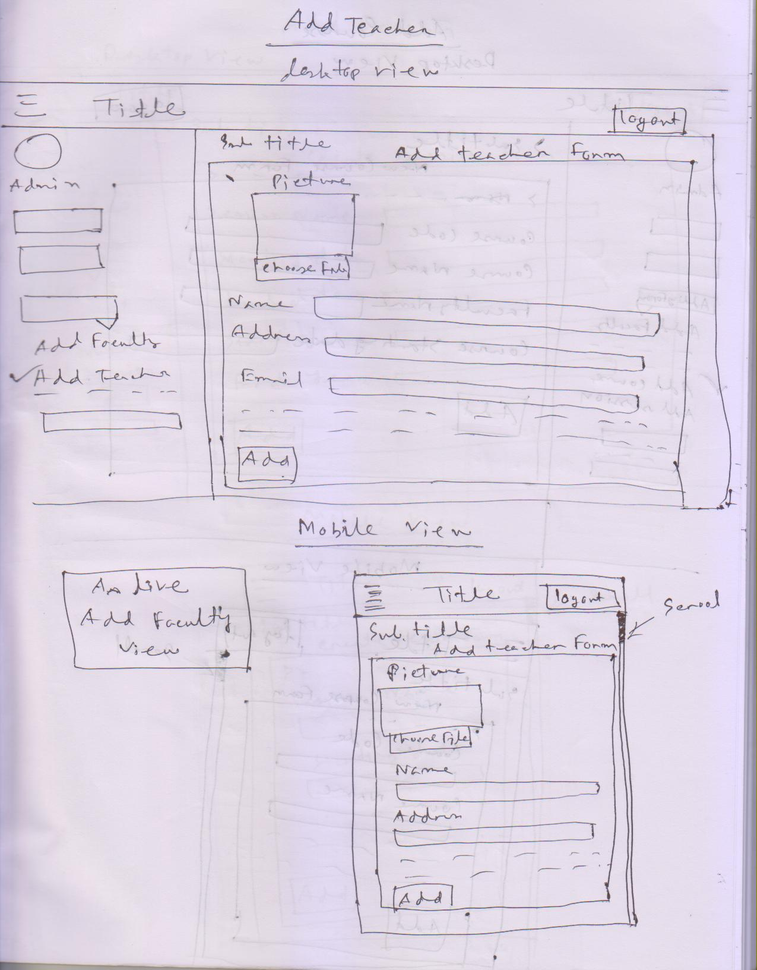

**Fig S.5:** Sketch for Add Teacher page in mobile view and desktop view.

Add Course

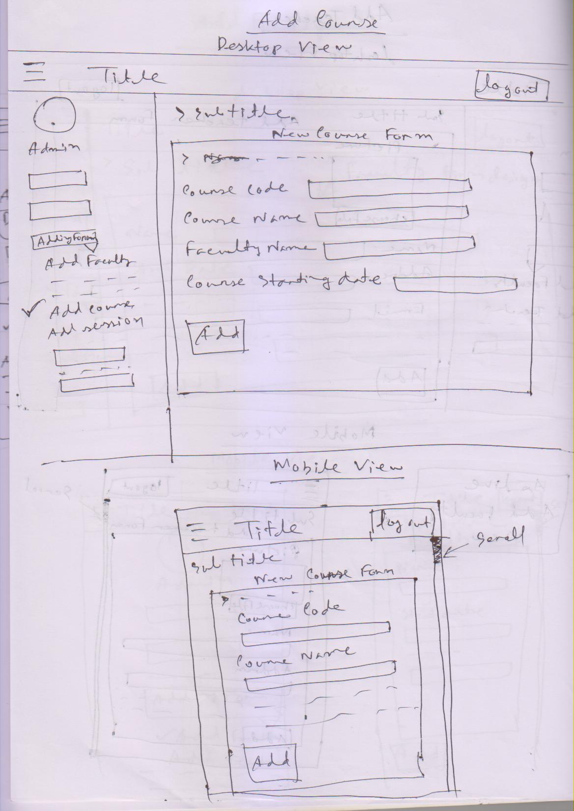

**Fig S.6:** Sketch for Add Course page in mobile view and desktop view.

Add Session

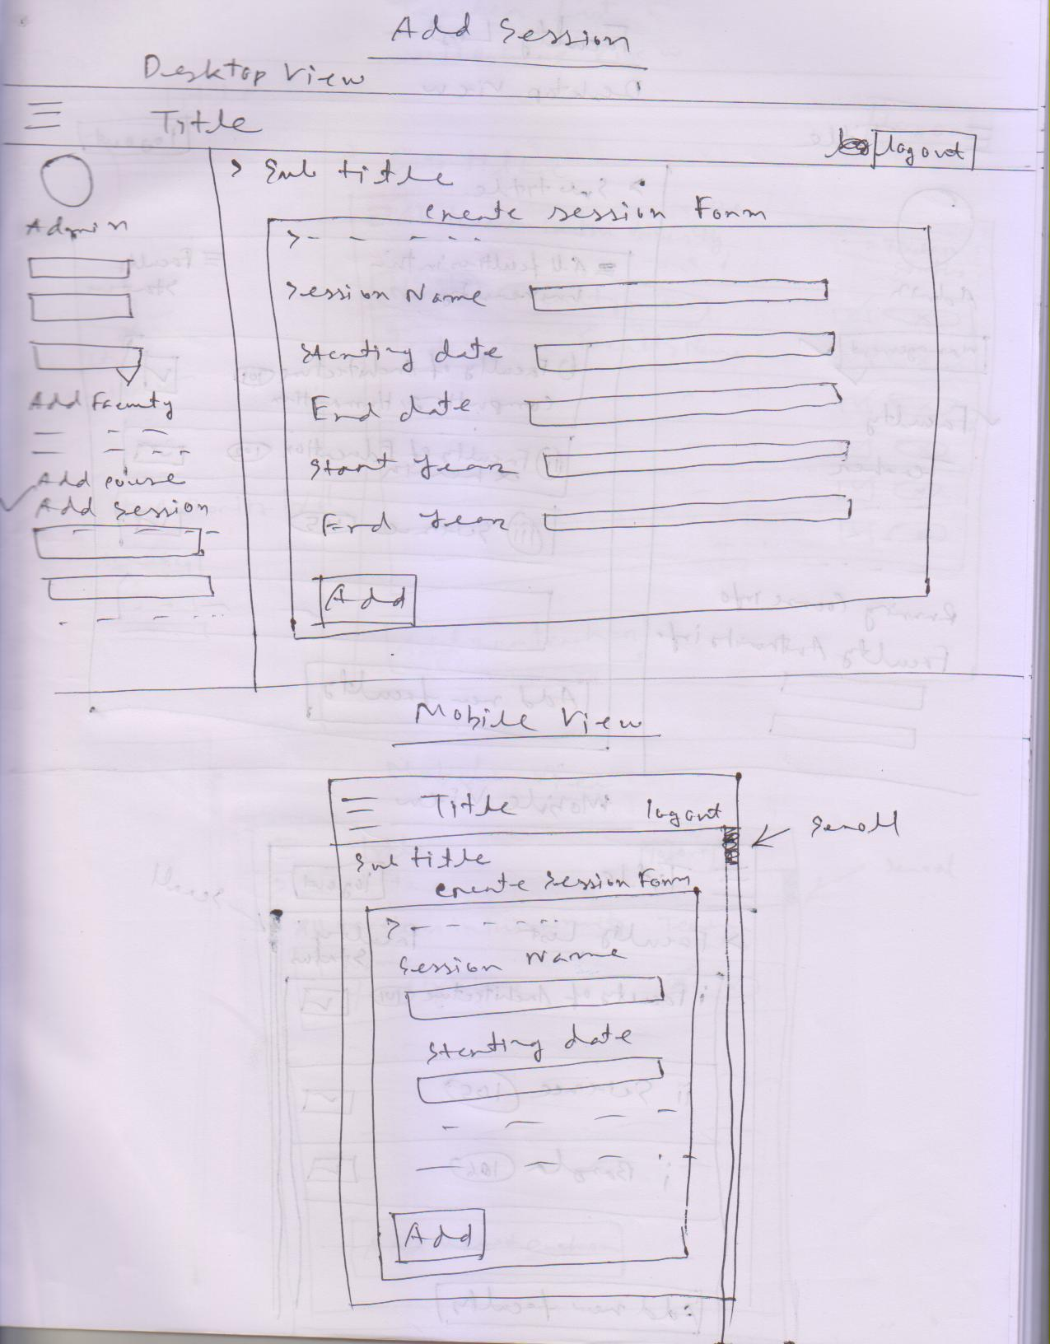

**Fig S.7:** Sketch for Add session page in mobile view and desktop view.

Faculty List

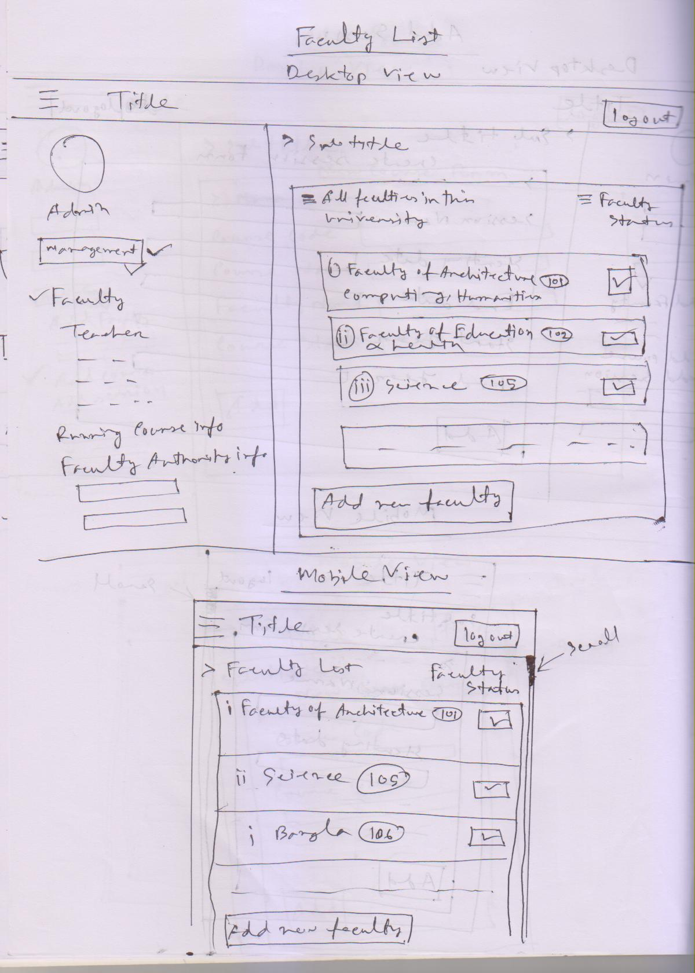

**Fig S.8:** Sketch for Faculty list page in mobile view and desktop view.

Teacher List

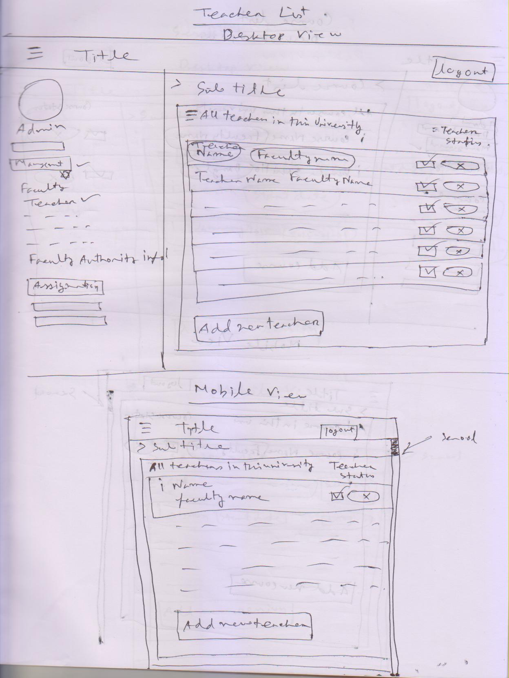

**Fig S.9:** Sketch for Teacher list page in mobile view and desktop view.

Course List

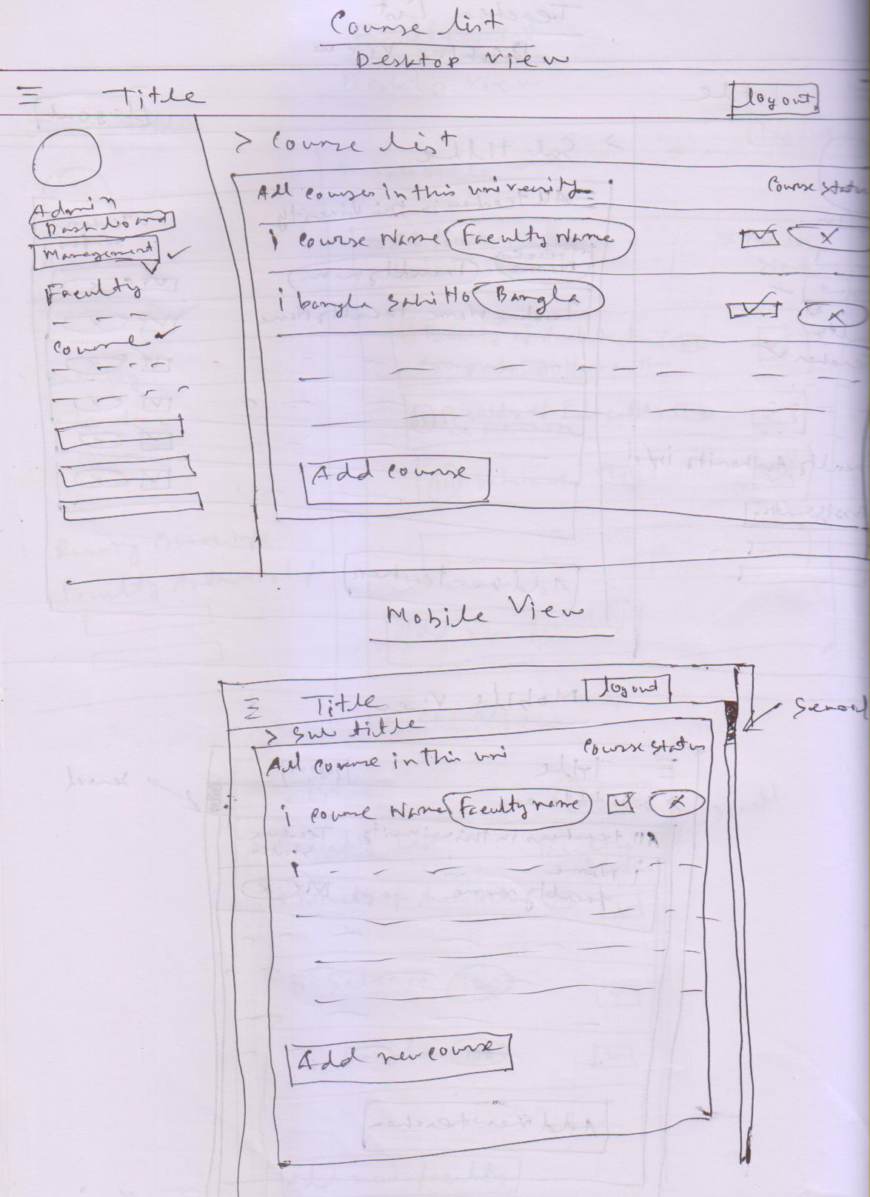

**Fig S.10:** Sketch for Course List page in mobile view and desktop view.

Session Lists

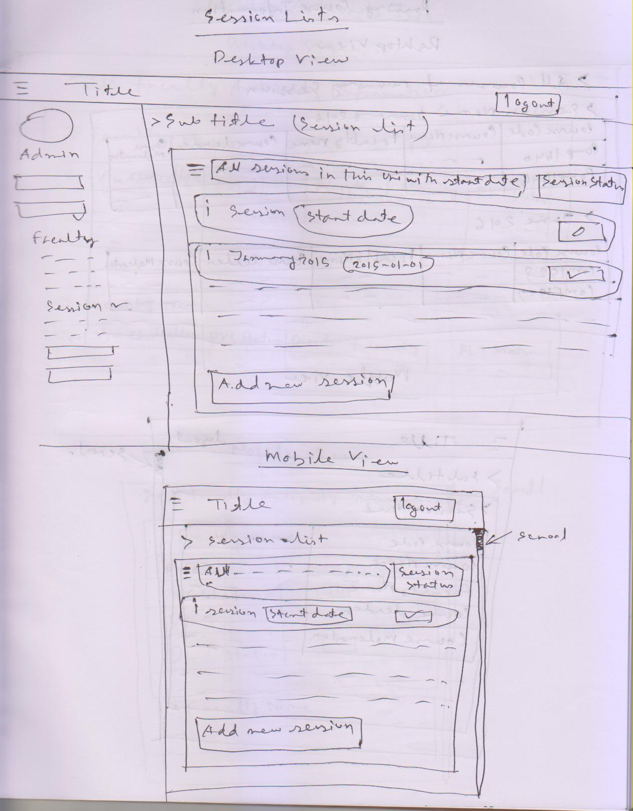

**Fig S.11:** Sketch for Session List page in mobile view and desktop view.

Running Course Information

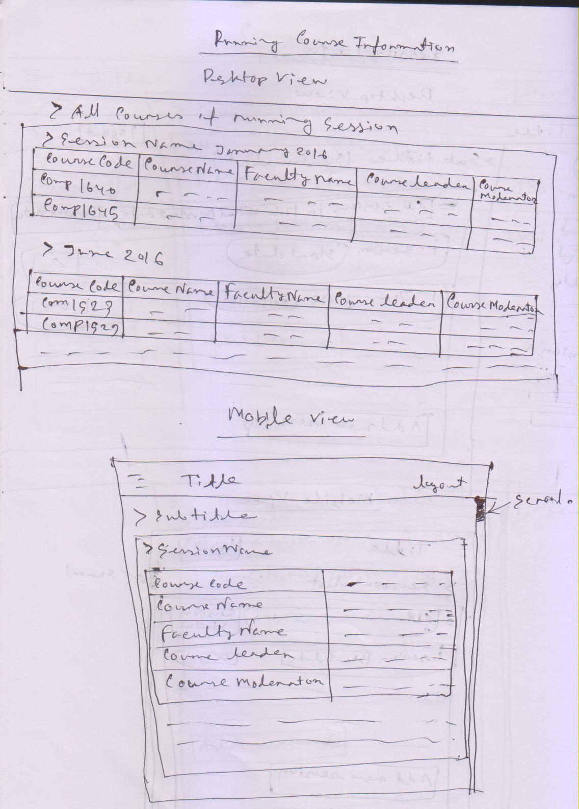

**Fig S.12:** Sketch for Running course information page in mobile view and desktop view.

Faculty Authority Info

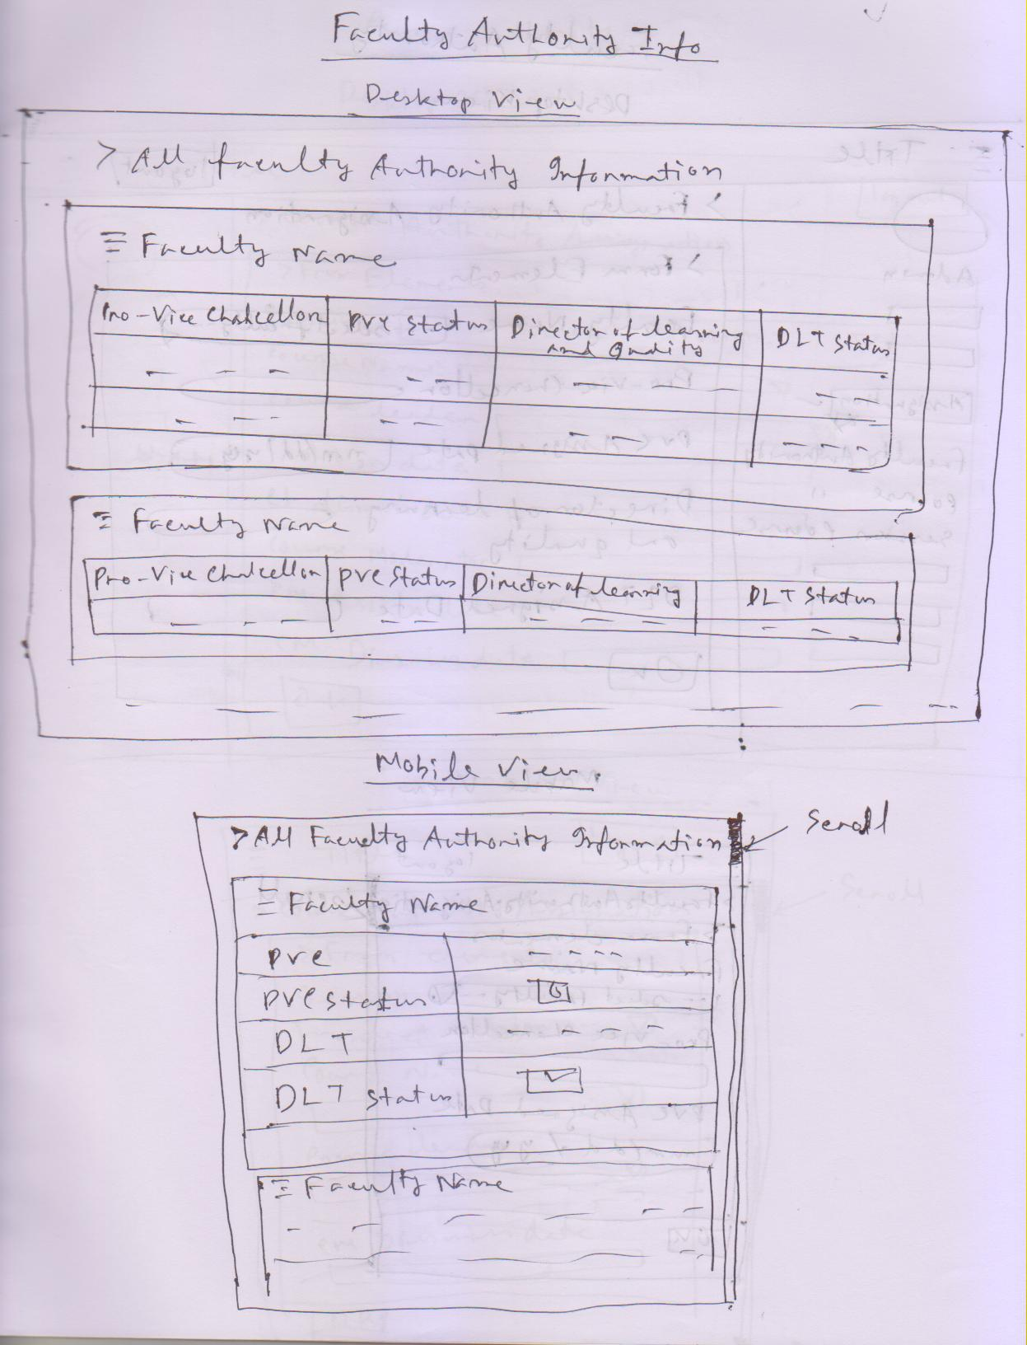

**Fig S.13:** Sketch for Faculty authority info page in mobile view and desktop view.

Faculty Authority

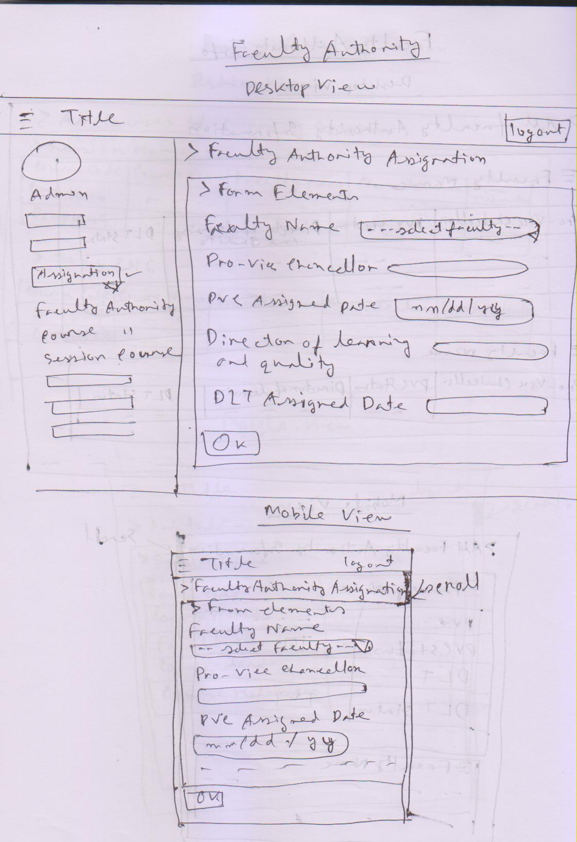

**Fig S.14:** Sketch for Faculty Authority page in mobile view and desktop view.

Course Authority

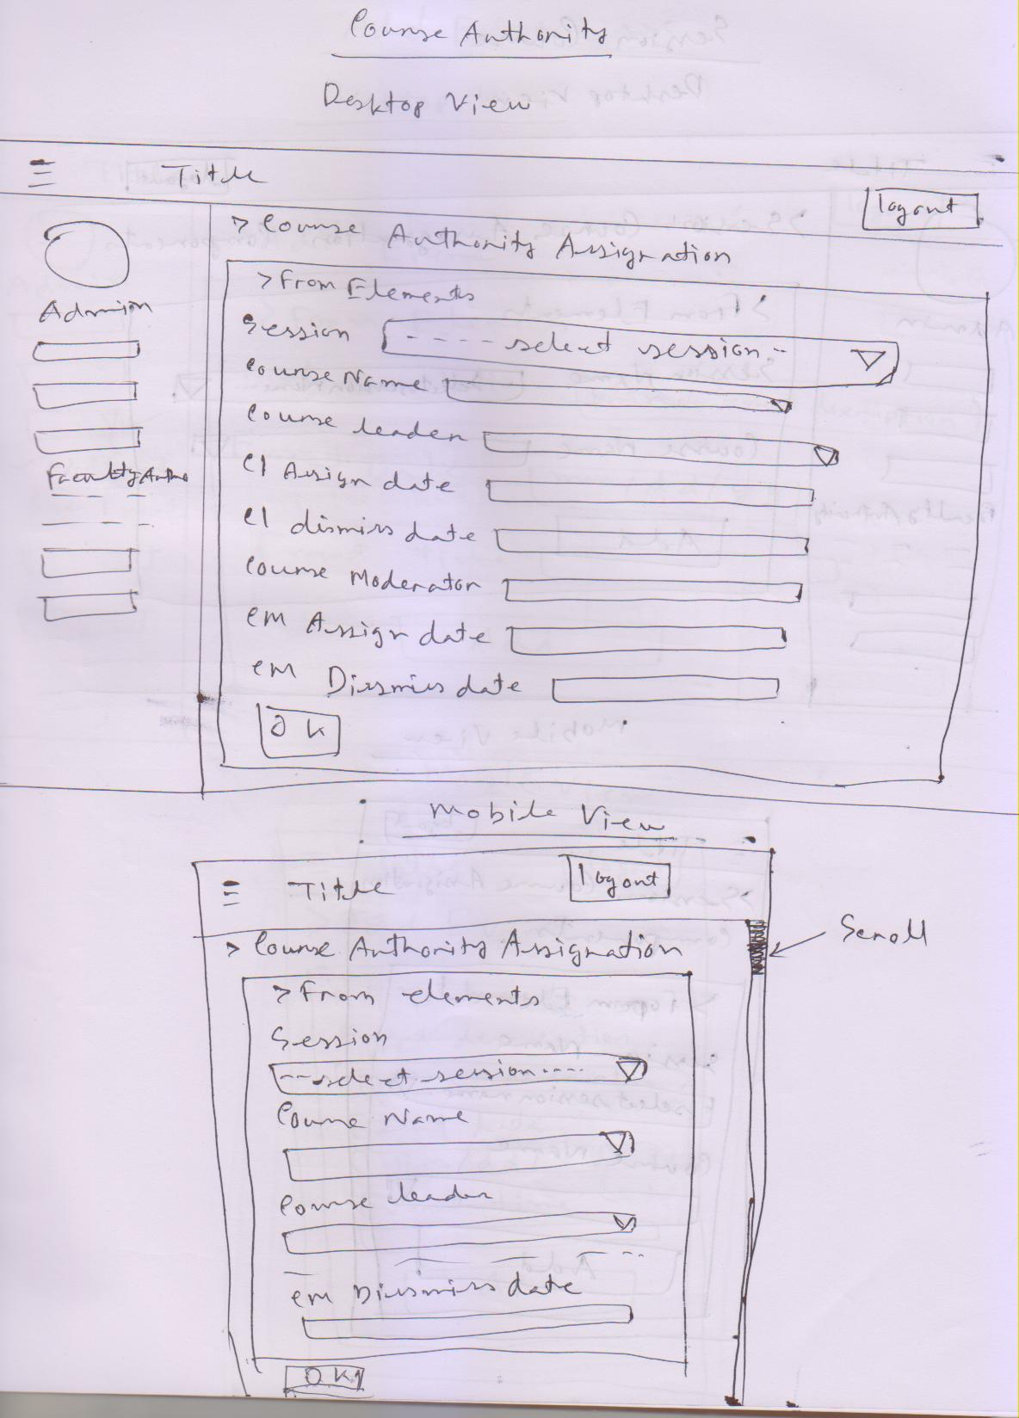

**Fig S.15:** Sketch for course authority page in mobile view and desktop view.

Session Course

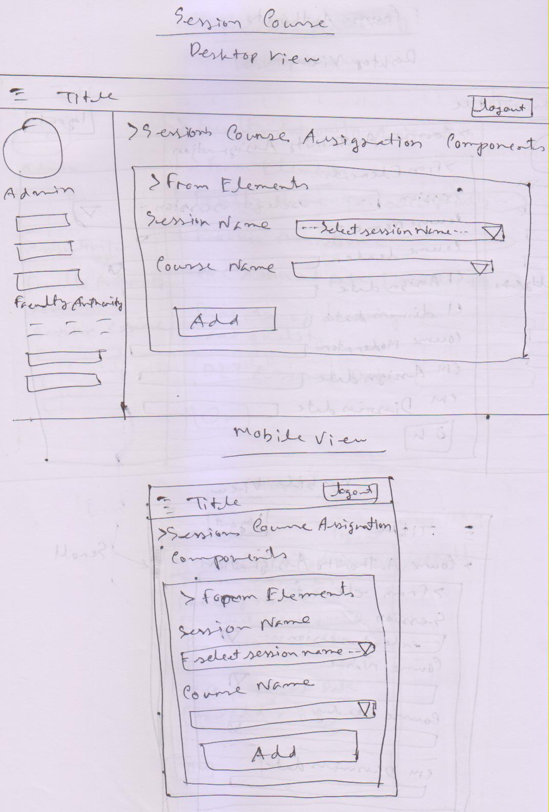

**Fig S.16:** Sketch for Session Course page in mobile view and desktop view.

Add Event

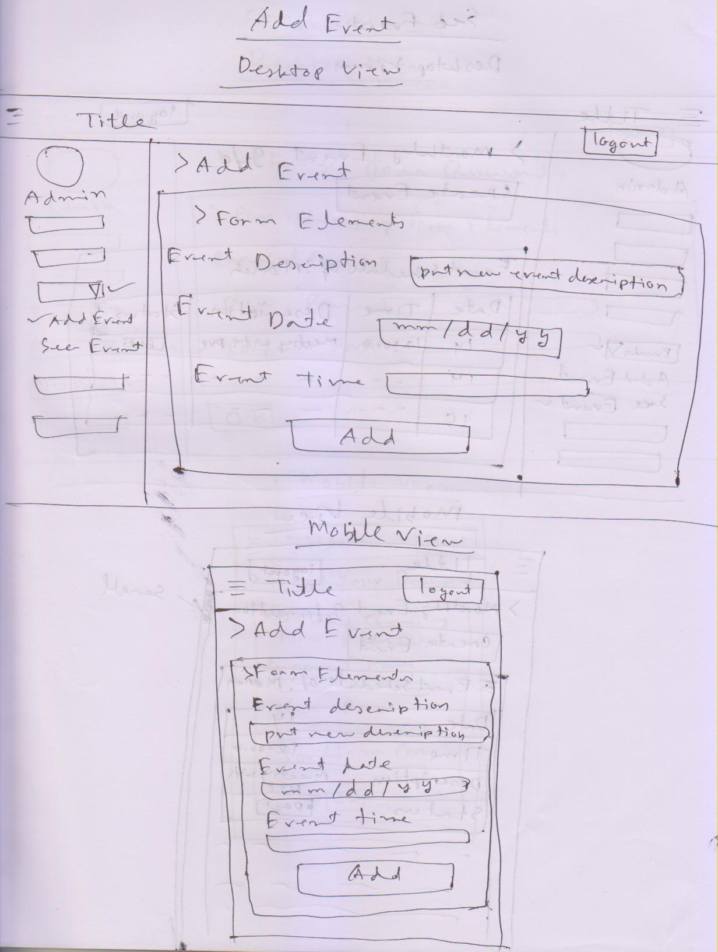

**Fig S.17:** Sketch for Add Event page in mobile view and desktop view.

See Event

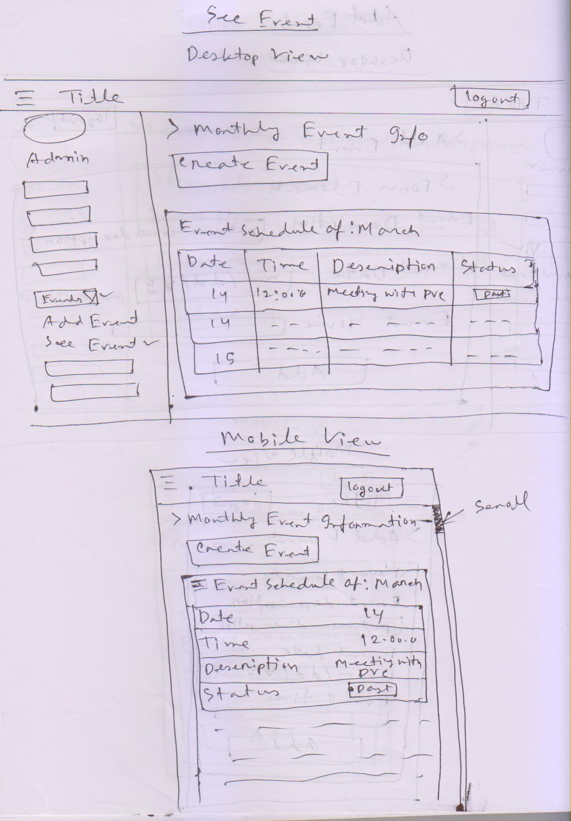

**Fig S.18:** Sketch for See Event page in mobile view and desktop view.

Change Password

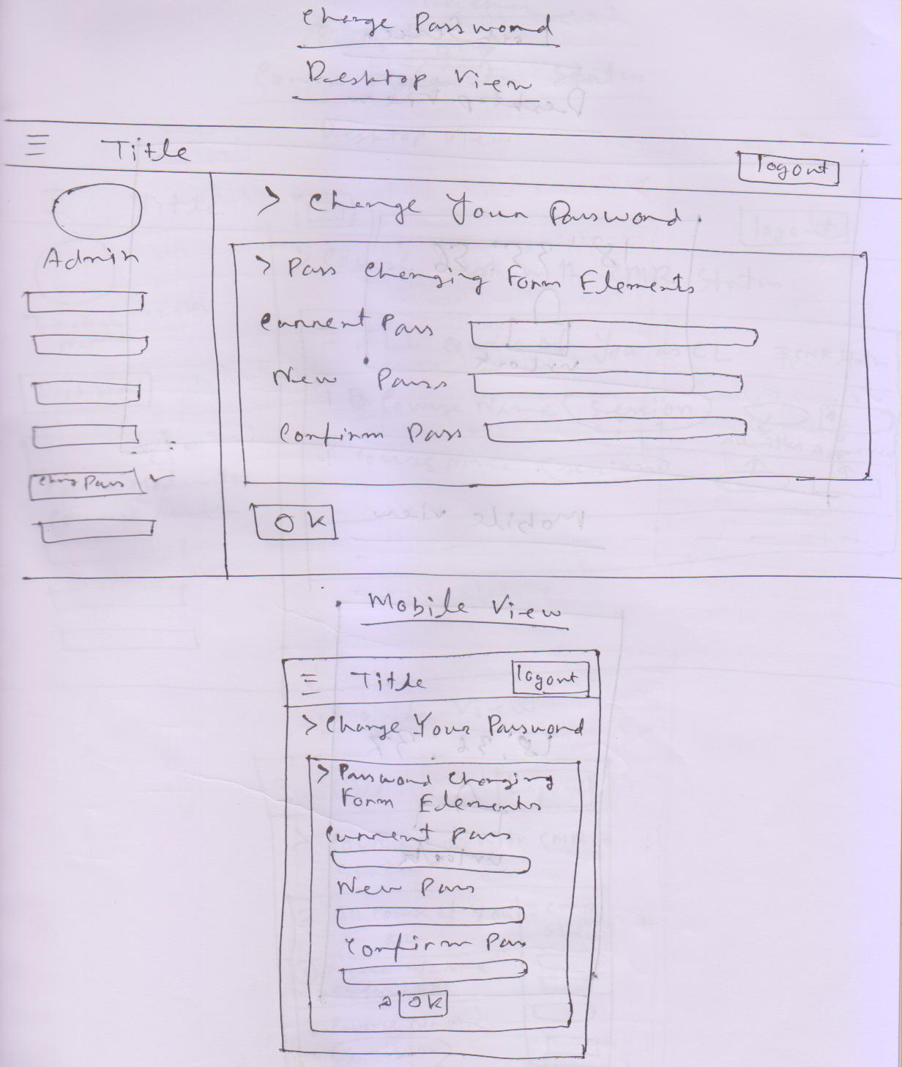

**Fig S.19:** Sketch for Change Password page in mobile view and desktop view.

Lock Screen

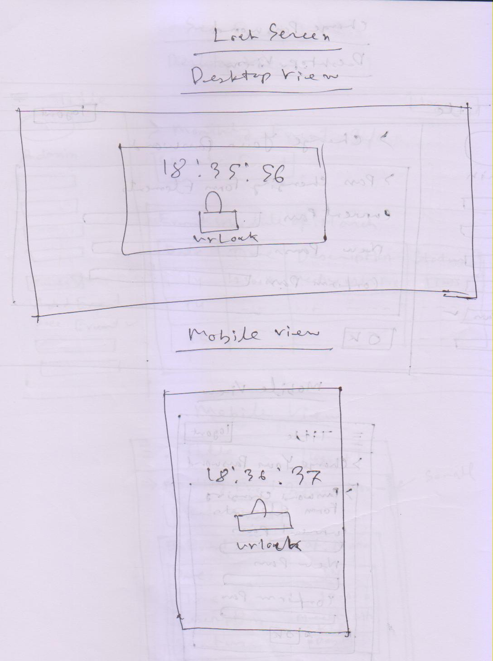

**Fig S.20:** Sketch for lock Screen page in mobile view and desktop view.

Course Leader Status

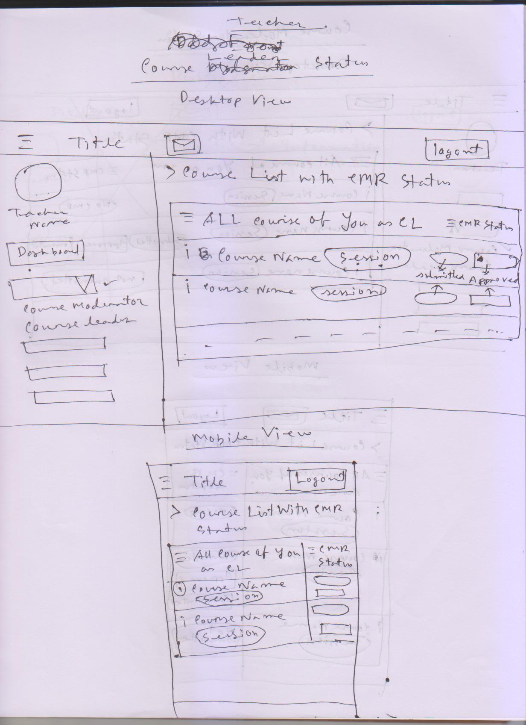

**Fig S.21:** Sketch for Course leader status page in mobile view and desktop view.

Course Moderator Status

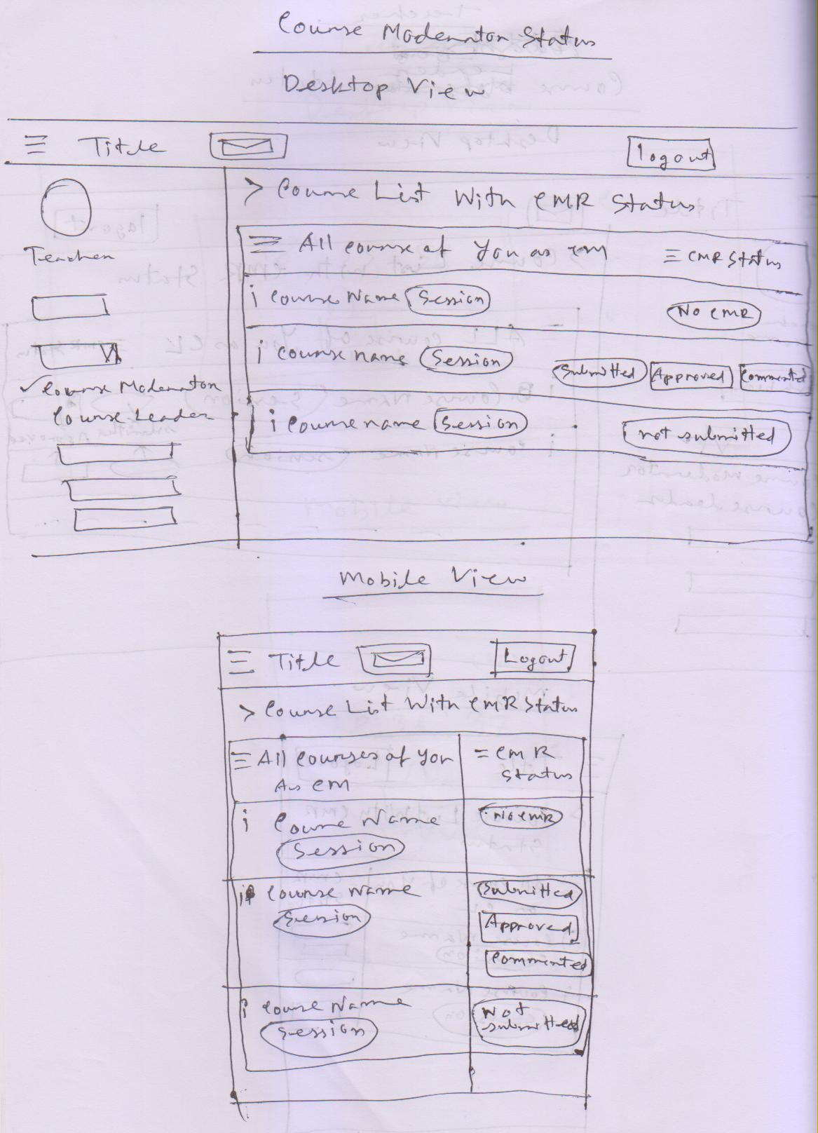

**Fig S.22:** Sketch for Course Moderator Status page in mobile view and desktop view.

See Profile

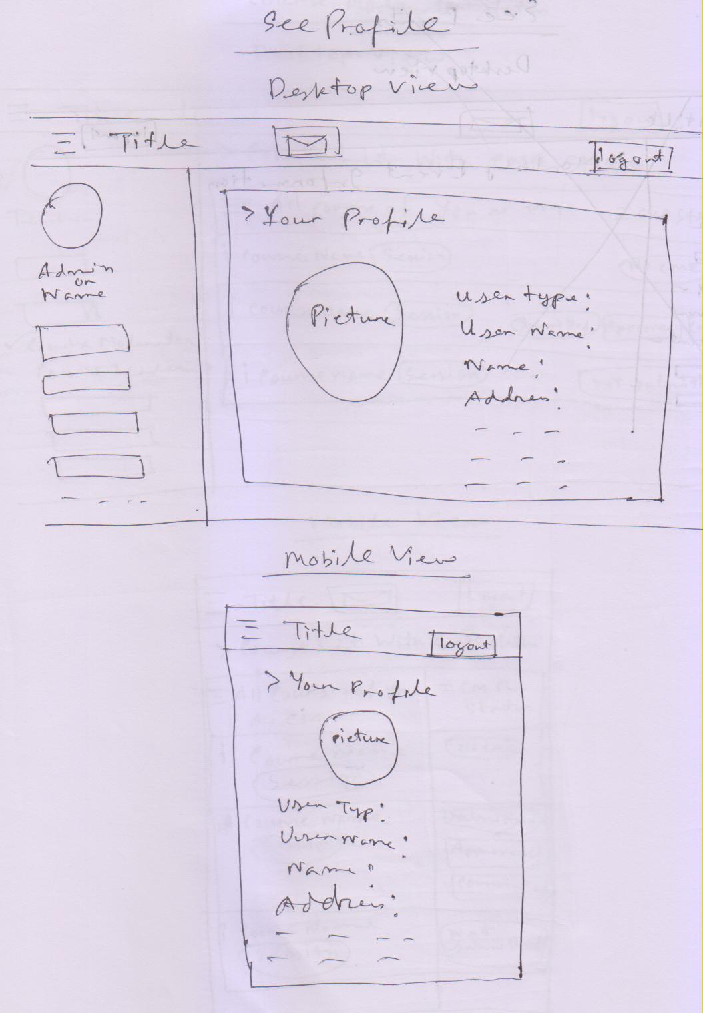

**Fig S.23:** Sketch for See Profile page in mobile view and desktop view.

Approved CMRs

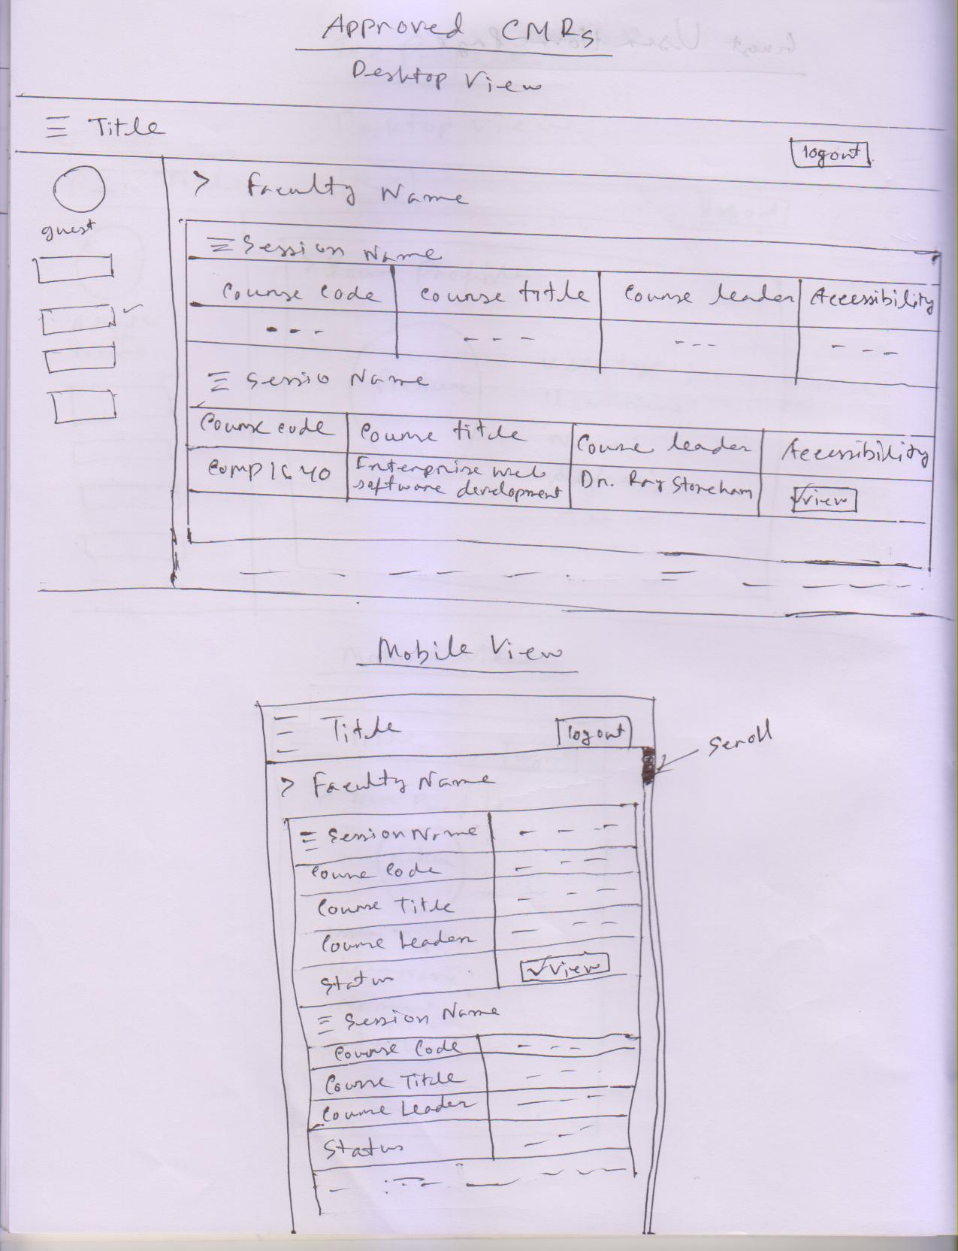

**Fig S.24:** Sketch for approved CMRs page in mobile view and desktop view.

Exception Reports Without CL/CM

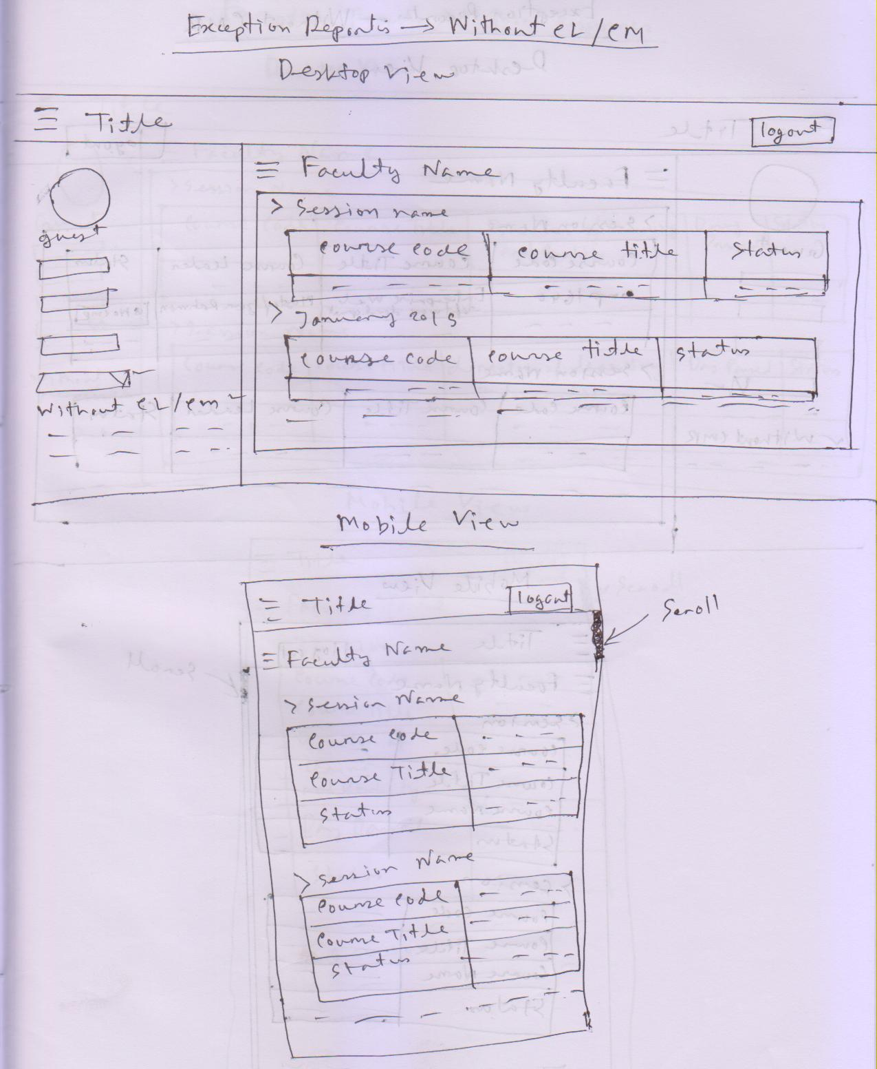

**Fig S.25:** Sketch for Exception Reports without CL/CM page in mobile view and desktop view.

Exception Reports Without CMR

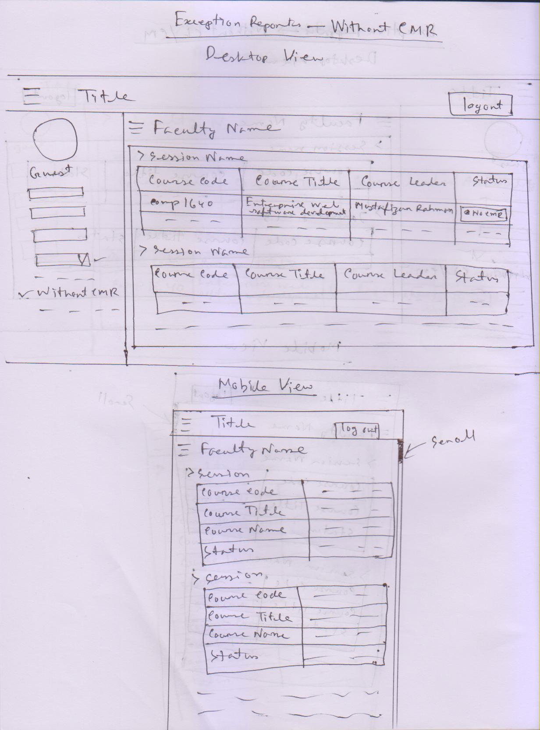

**Fig S.26:** Sketch for Exception Reports without CMR page in mobile view and desktop view.

Exception Reports without Responses

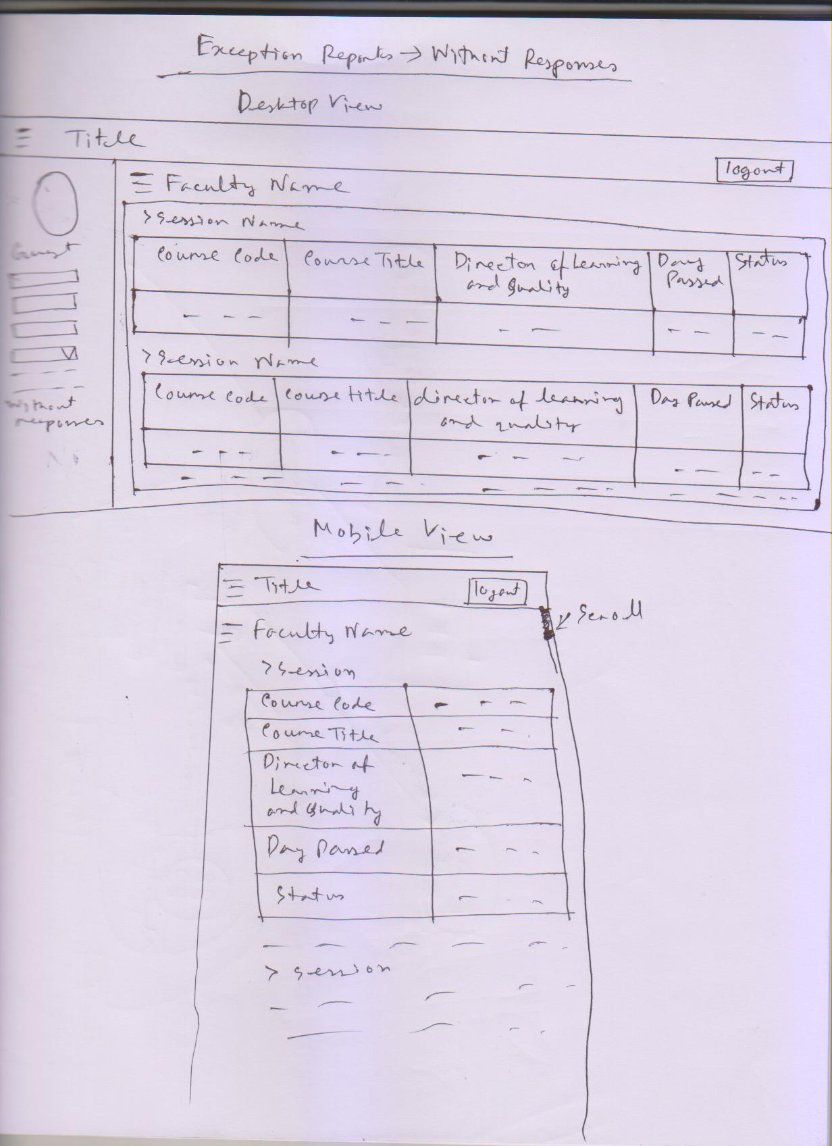

**Fig S.27:** Sketch for Exception Reports without responses page in mobile view and desktop view.

**High Fidelity prototype (wireframe modeling):** In this part I am giving the secondary design which I have made for making the original site.

Login Page

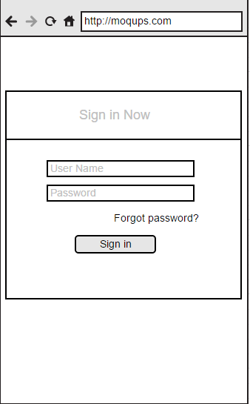

**Fig W.1:** Wire frame model for login page.

Admin Home page

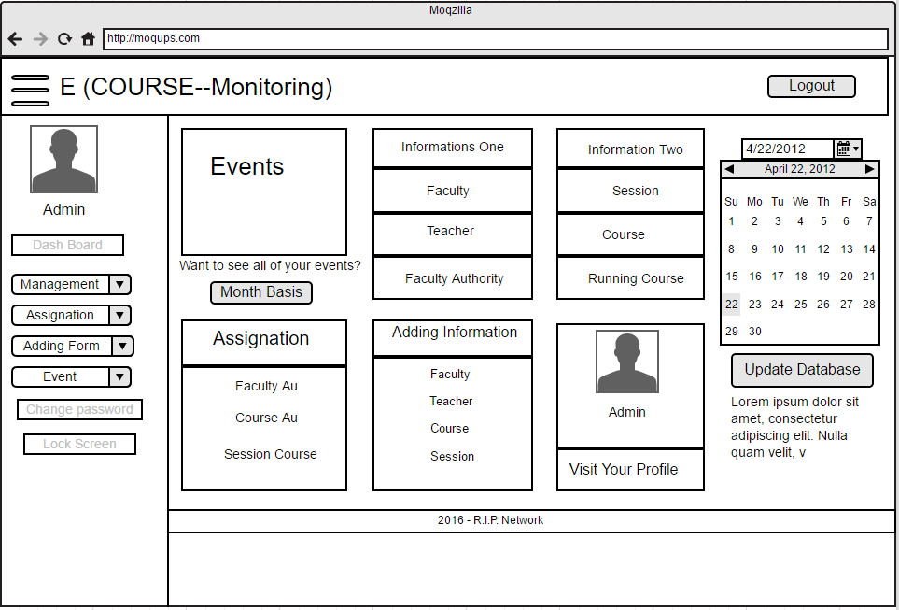

**Fig W.2:** Wire frame model for Admin home page in desktop view.

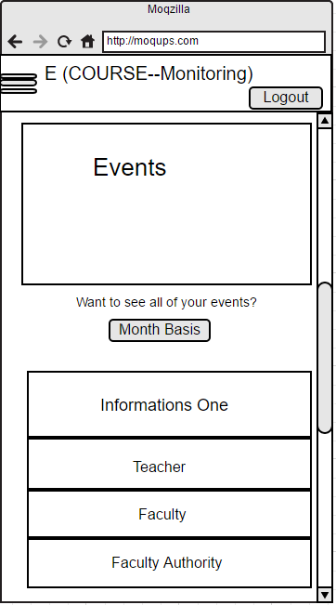

**Fig W.3:** Wire frame model for Admin home page in mobile view.

Add Faculty

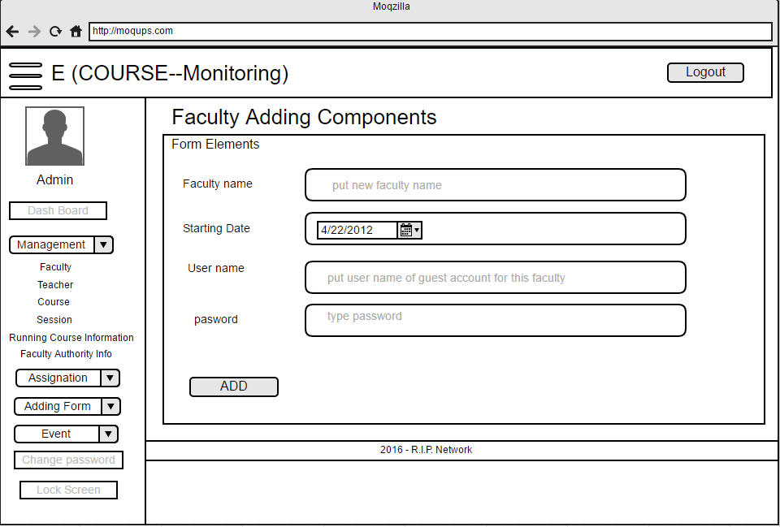

**Fig W.4:** Wire frame model for Add Faculty page in desktop view.

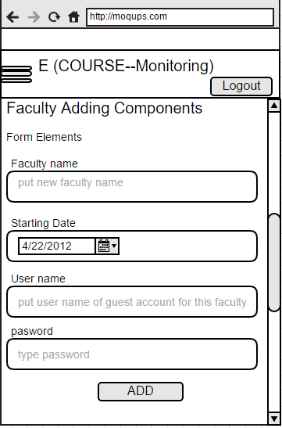

**Fig W.5:** Wire frame model for Add faculty page in mobile view.

Faculty List

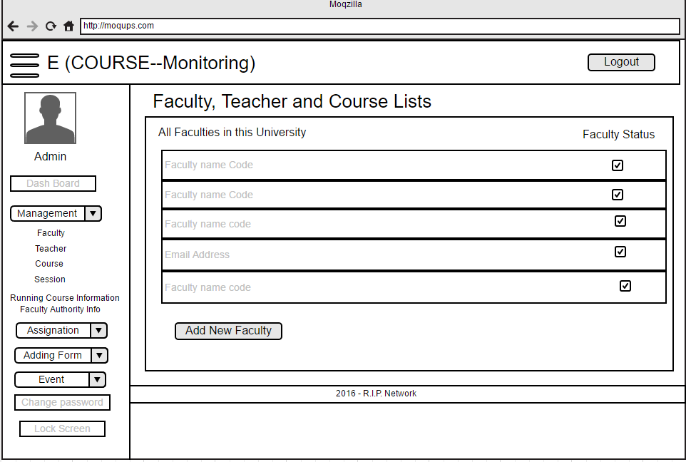

**Fig W.6:** Wire frame model for Faculty list page in desktop view.

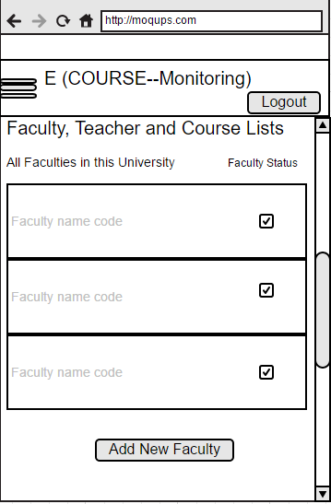

**Fig W.7:** Wire frame model for Faculty list page in mobile view.

Running Course Information

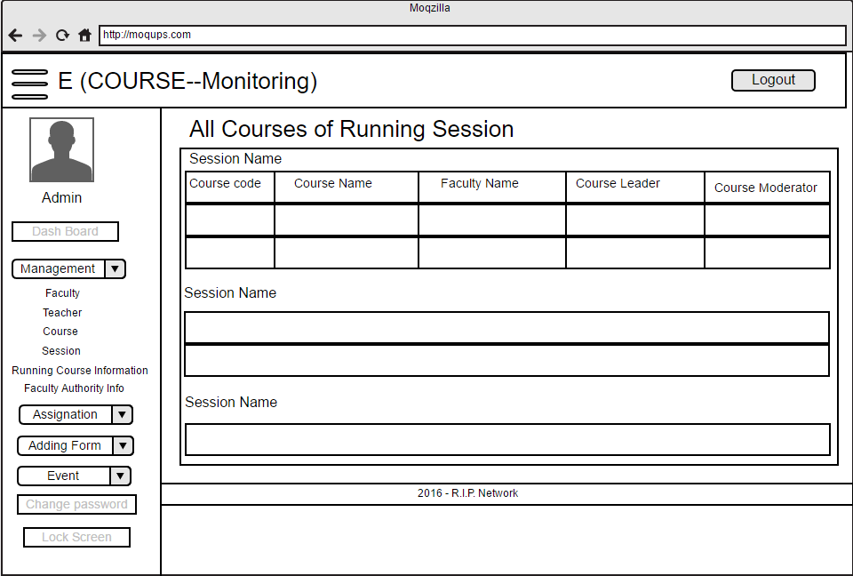

**Fig W.8:** Wire frame model for running course information page in desktop view.

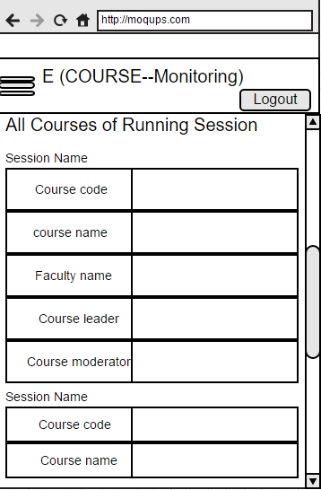

**Fig W.9:** Wire frame model for running course information page in mobile view.

Teacher List

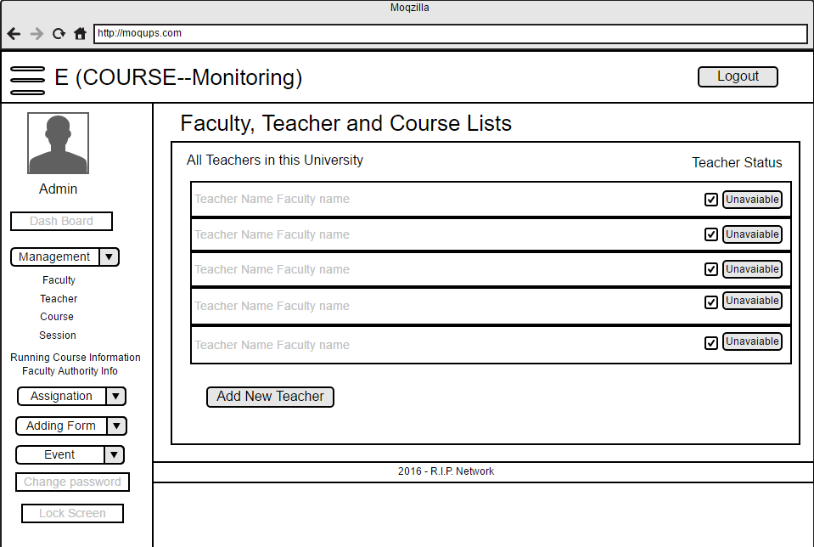

**Fig W.10:** Wire frame model for Teacher list page in desktop view.

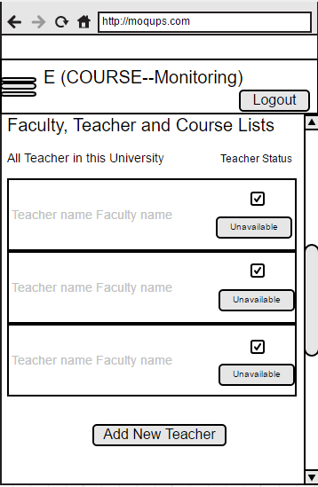

**Fig W.11:** Wire frame model for Teacher list page in mobile view.

See Event List

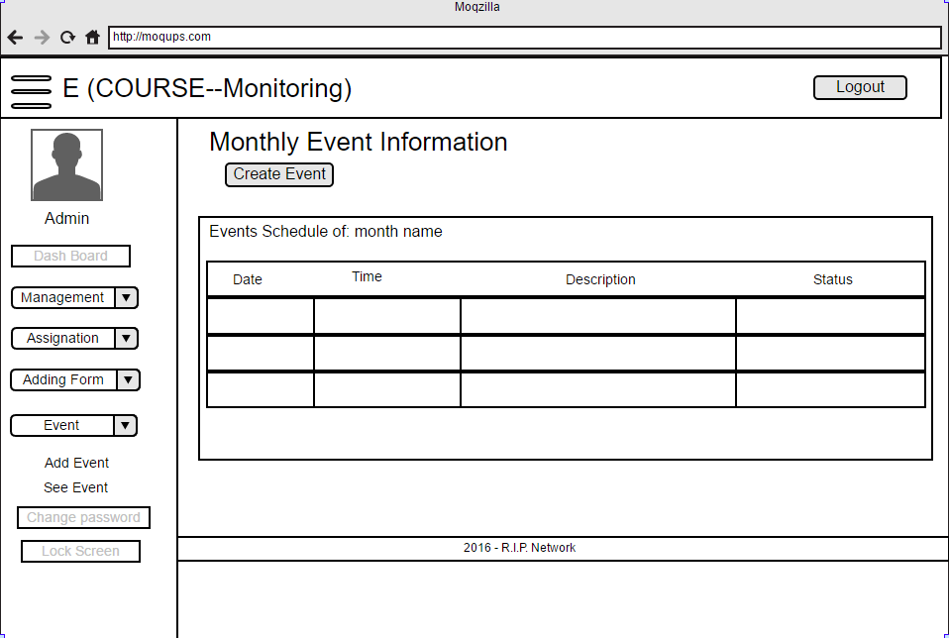

**Fig W.12:** Wire frame model for See Event page in desktop view.

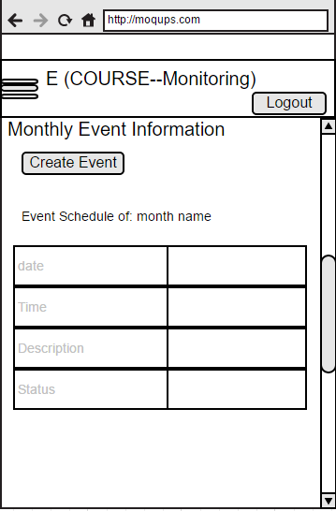

**Fig W.13:** Wire frame model for See Event List page in mobile view.

Change Password

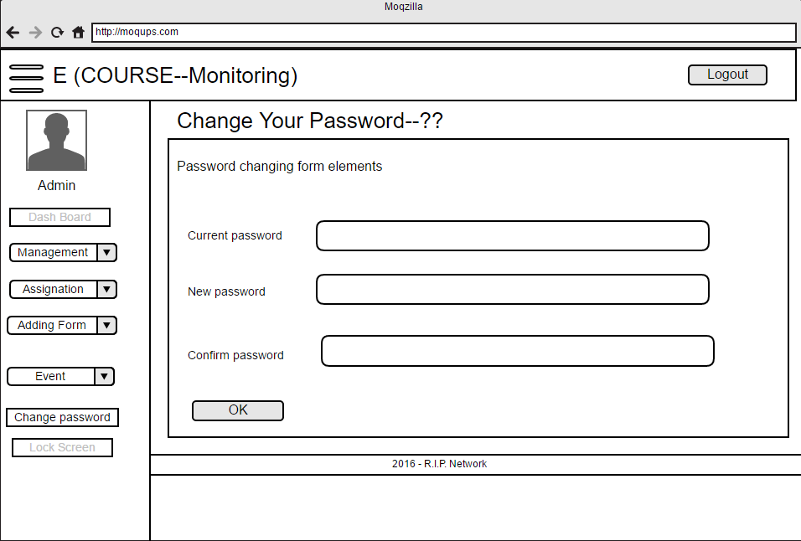

**Fig W.14:** Wire frame model for Change Password page in desktop view.

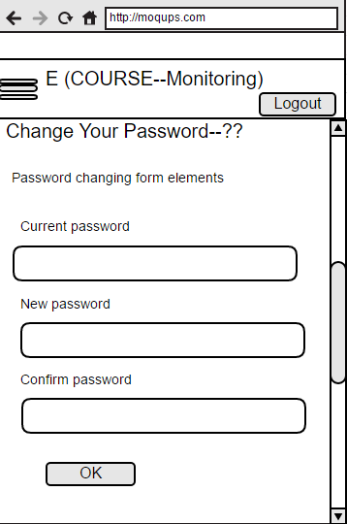

**Fig W.15:** Wire frame model for Change Password page in mobile view.

Course Leader Status

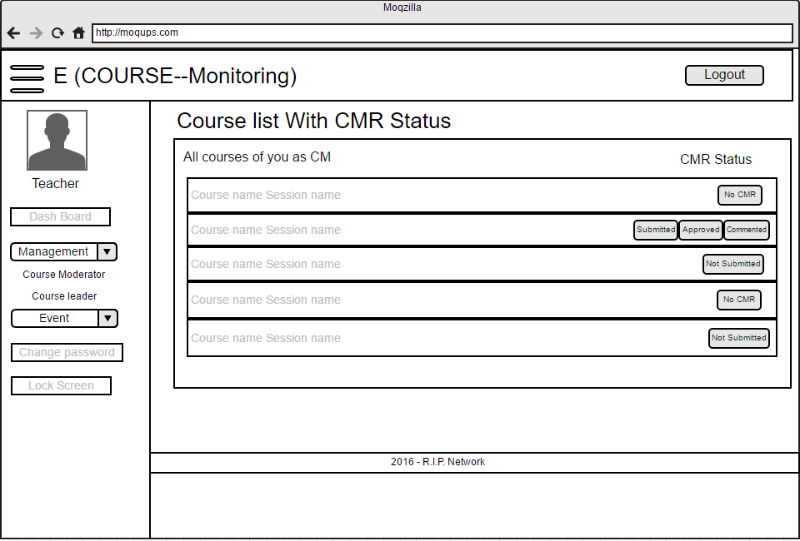

**Fig W.16:** Wire frame model for course leader status page in desktop view.

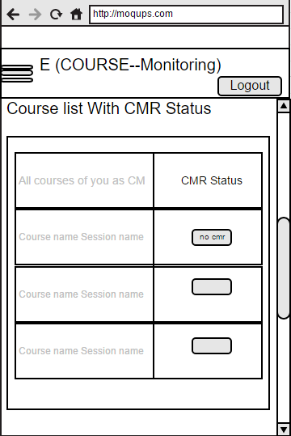

**Fig W.17:** Wire frame model for course leader status page in mobile view.

Exception report without CL/CM

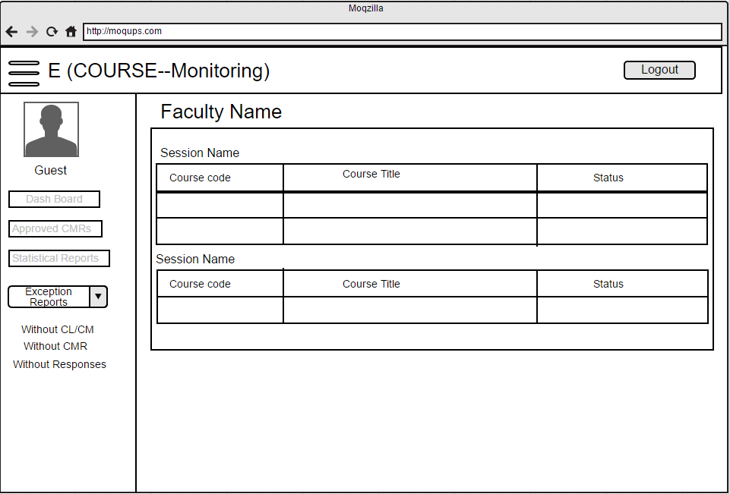

**Fig W.18:** Wire frame model for Exception report without CL/CM page in desktop view.

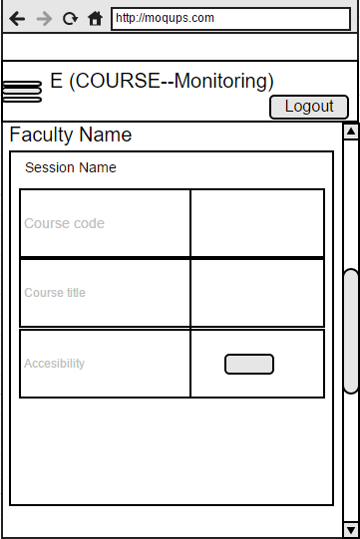

**Fig W.19:** Wire frame model for Exception reports without CL/CM page in mobile view.

Faculty Authority

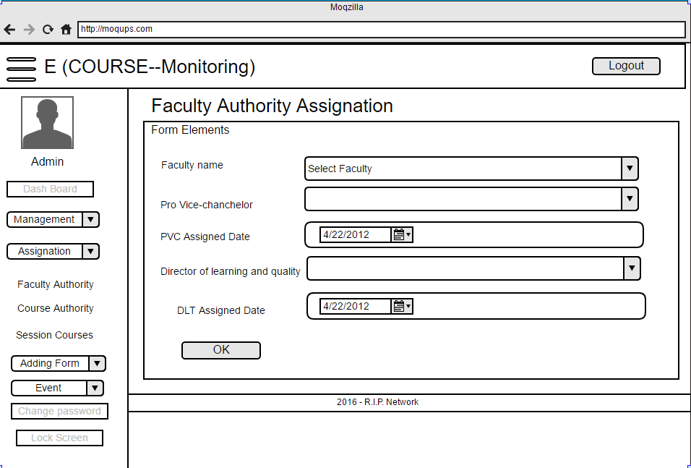

**Fig W.20:** Wire frame model for Faculty Authority page in desktop view.

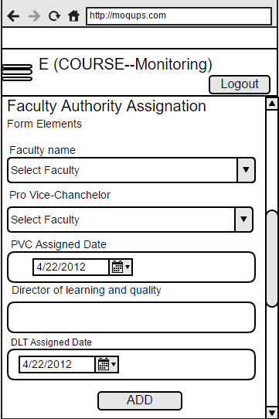

**Fig W.21:** Wire frame model for Faculty Authority page in mobile view.

Approved CMRs List

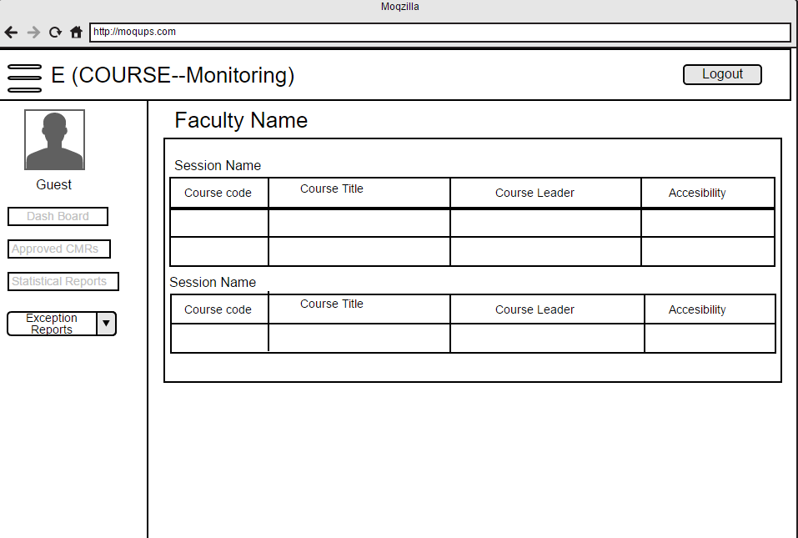

**Fig W.22:** Wire frame model for Approved CMRs page in desktop view.

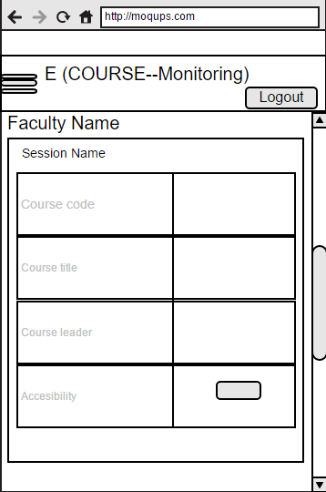

**Fig W.2:** Wire frame model for Approved CMRs page in mobile view.

**Final Outcome (UI Design) of the system:** In this part I am giving the original pages which I have made for the system.

**Login Page**

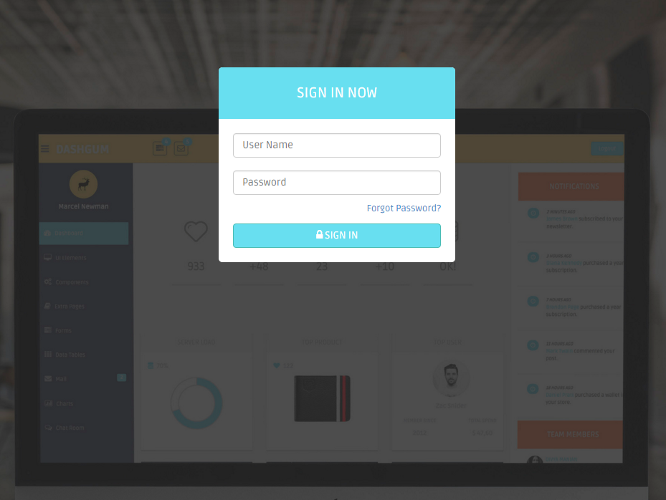

**Fig F.1:** Login page desktop view of the system.

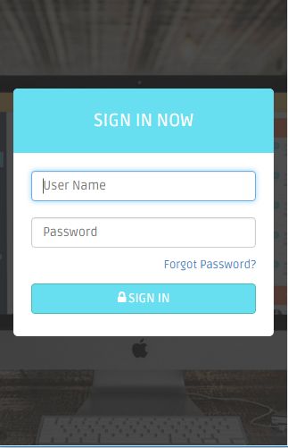

**Fig F.1.1:** Login page mobile view of the system.

**Admin Dashboard**

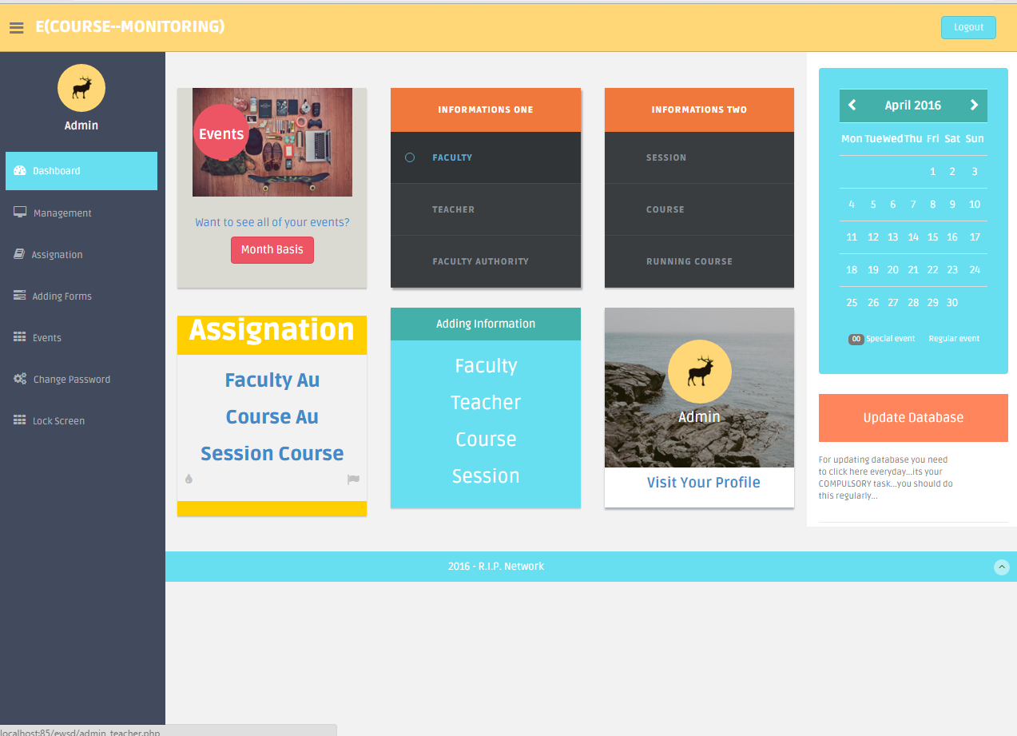

**Fig F.2:** Admin dashboard page desktop view of the system.

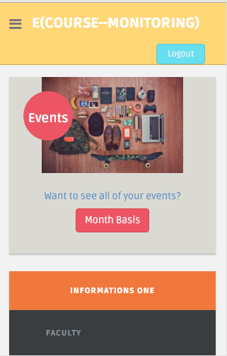

**Fig F.2.1:** Admin dashboard page mobile view of the system.

**Faculty list Page**

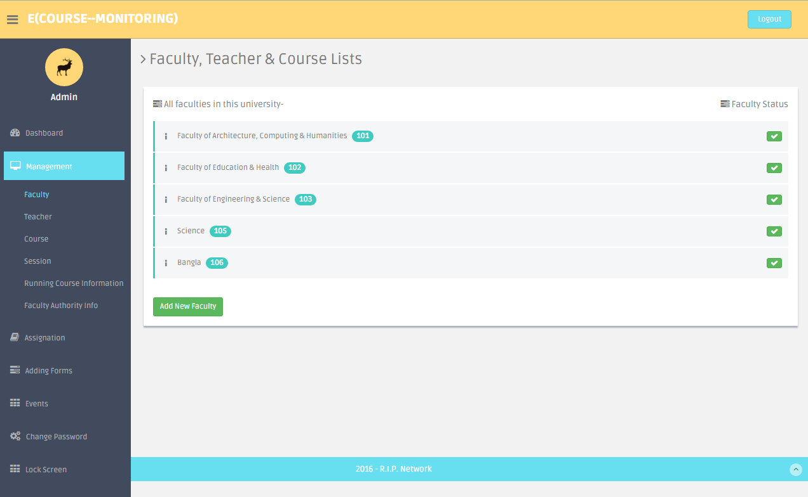

**Fig F.3:** Faculty list page desktop view of the system.



**Fig F.3.1:** Faculty list page mobile view of the system.

**Teacher list Page**

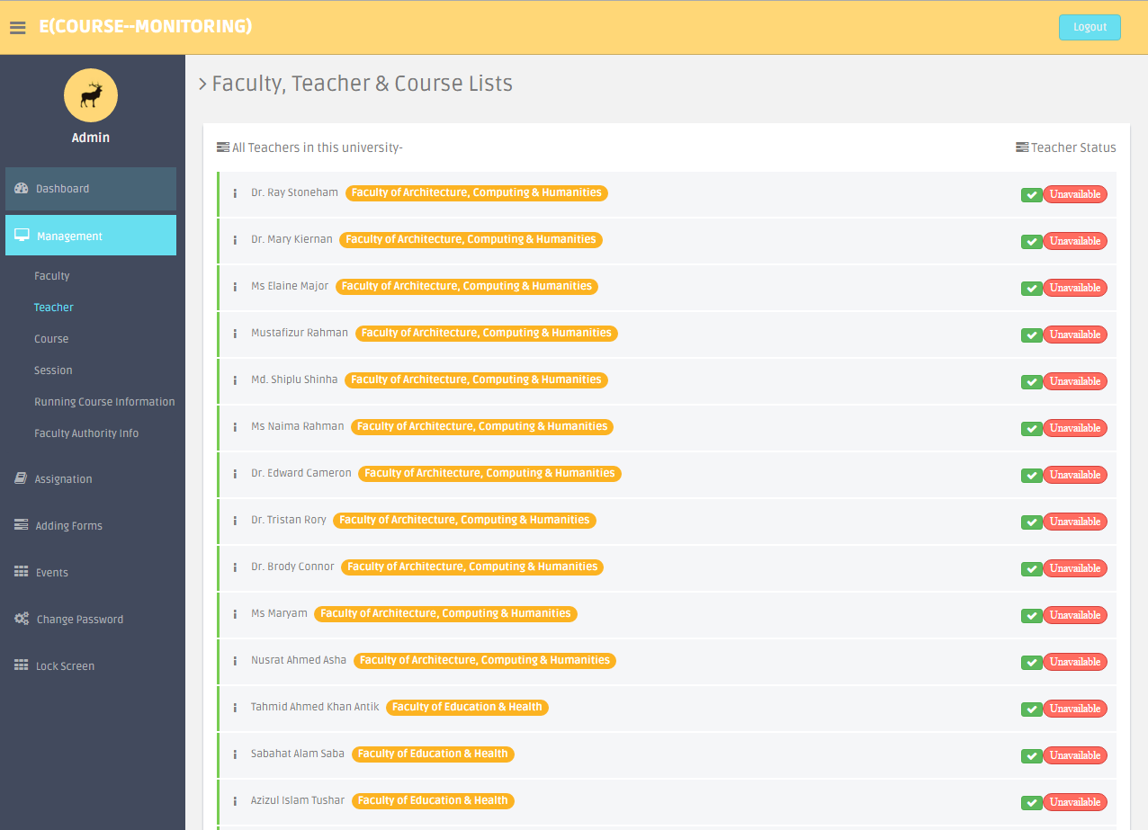

**Fig F.4:** Teacher list page desktop view of the system.

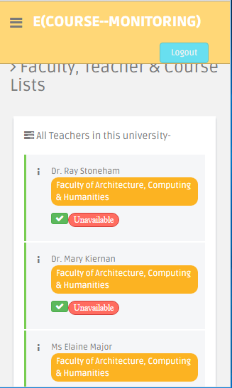

**Fig F.4.1:** Teacher list page mobile view of the system.

**Course list Page**

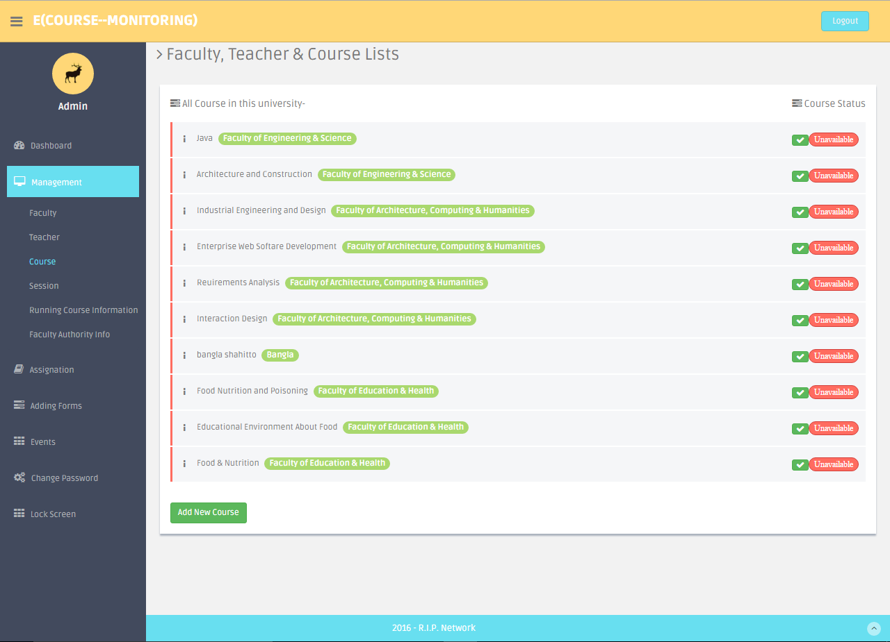

**Fig F.5:** Course list page desktop view of the system.

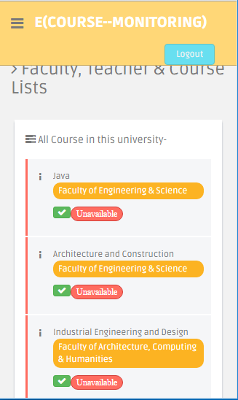

**Fig F.5.1:** Course list page mobile view of the system.

**Session list Page**

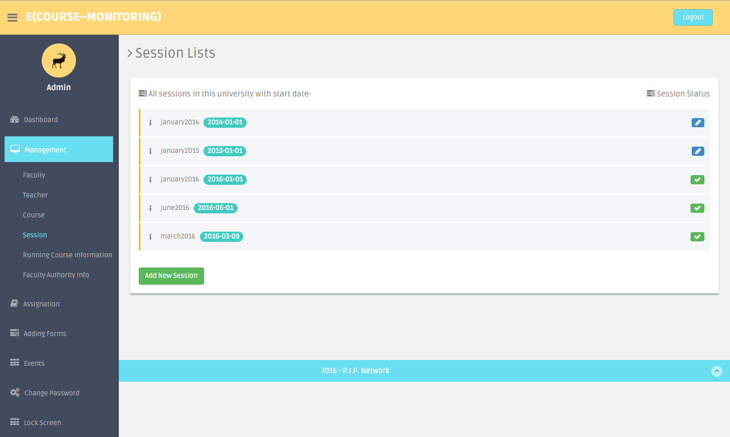

**Fig F.6:** Session list page desktop view of the system.

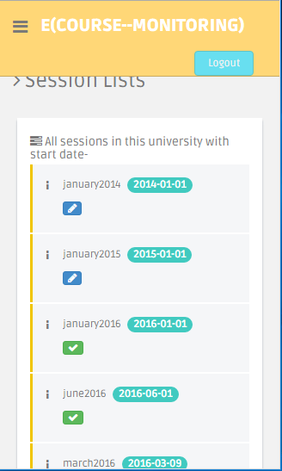

**Fig F.6.1:** Session list page mobile view of the system.

**Running Course Information Page**

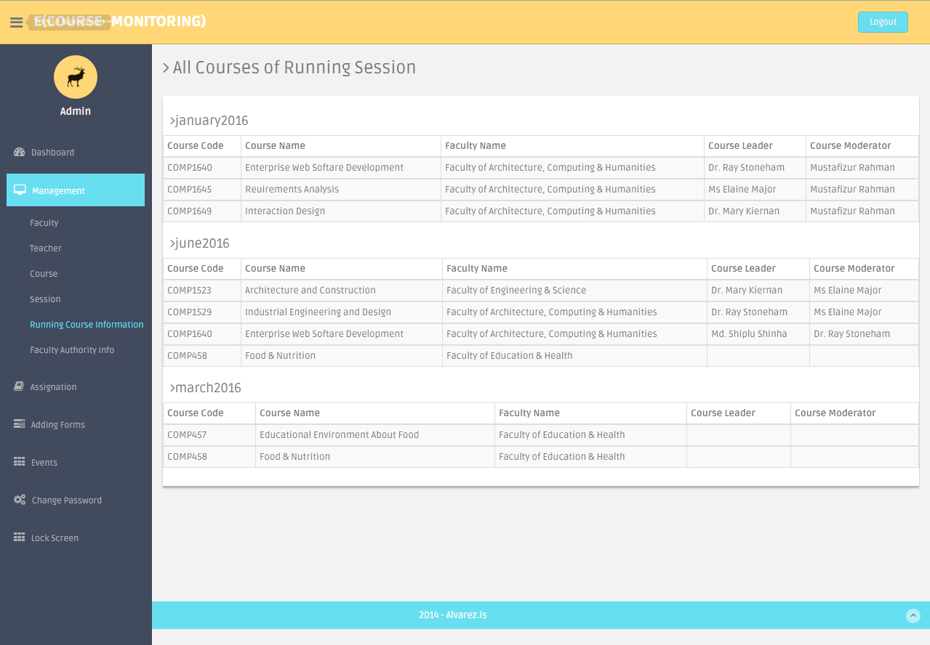

**Fig F.6:** Running course information page desktop view of the system.

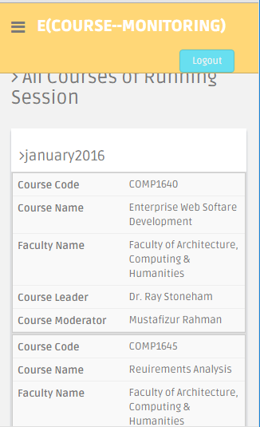

**Fig F.6.1:** Running course information page mobile view of the system.

**Faculty Authority Info Page**

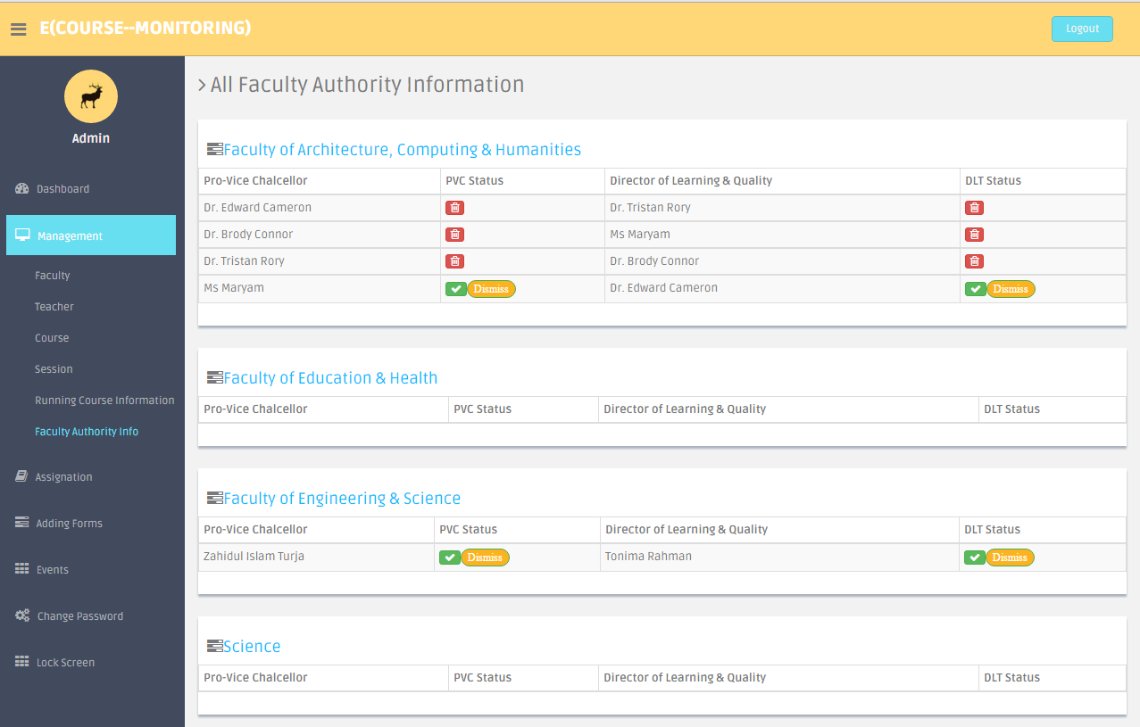

**Fig F.7:** Faculty Authority information page desktop view of the system.

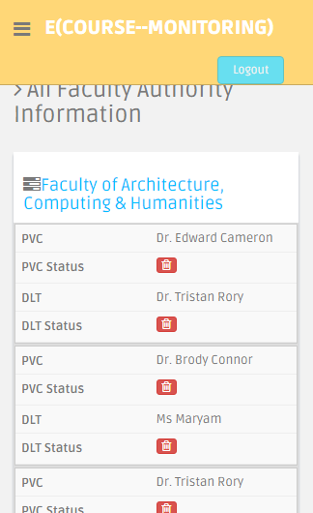

**Fig F.7.1:** Faculty Authority information page mobile view of the system.

**Assignation of Faculty Page**

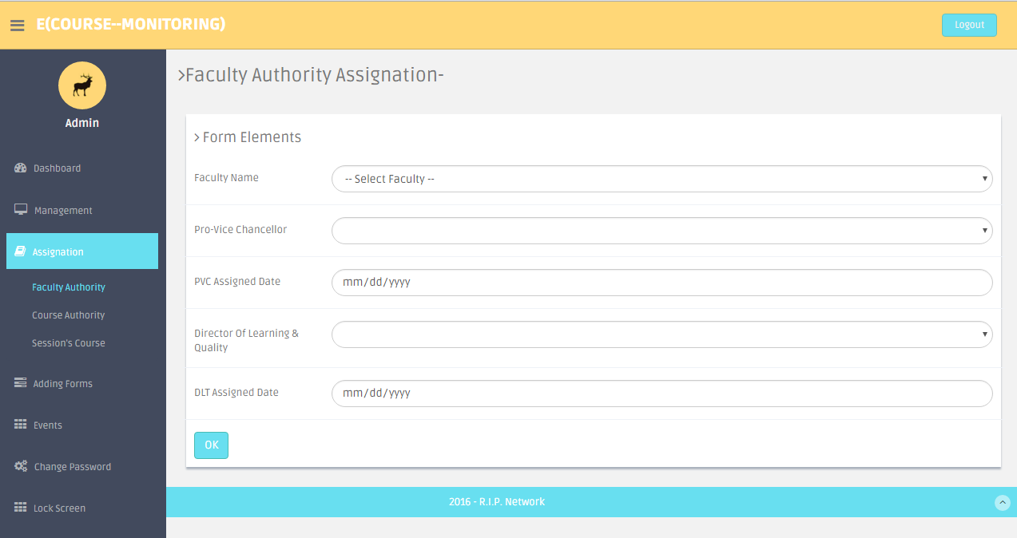

**Fig F.8:** Assignation of new Faculty page desktop view of the system.

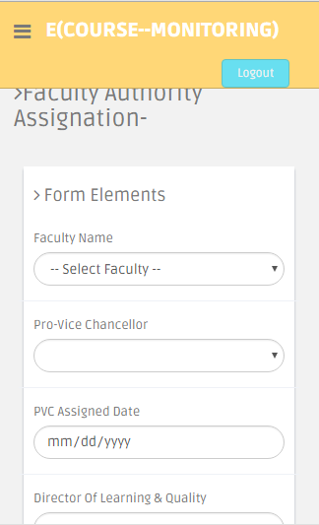

**Fig F.8.1:** Assignation of new Faculty page mobile view of the system.

**Course Authority Assign Page**

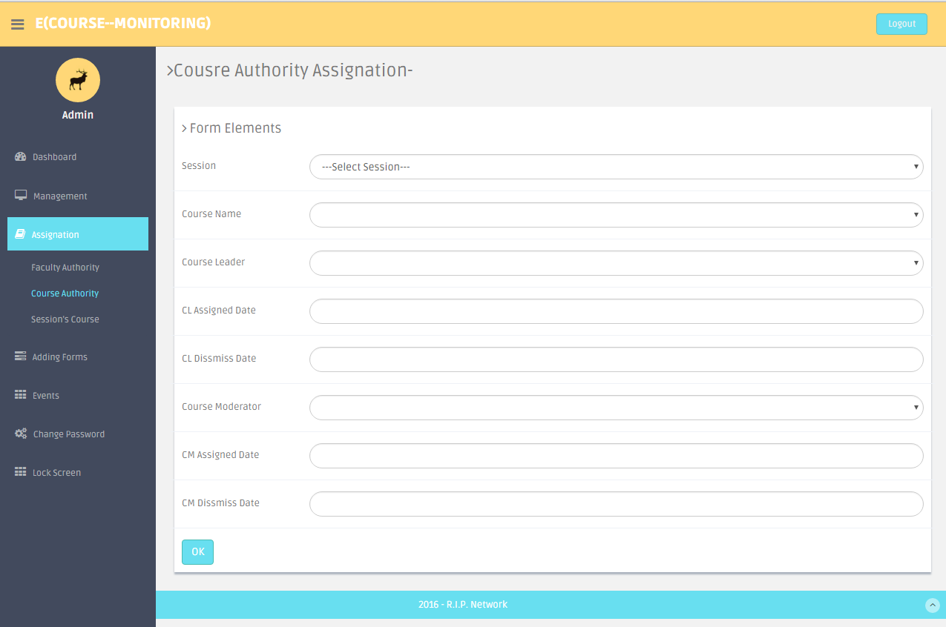

**Fig F.9.1:** Assign new course authority pageDesktop view of the system.

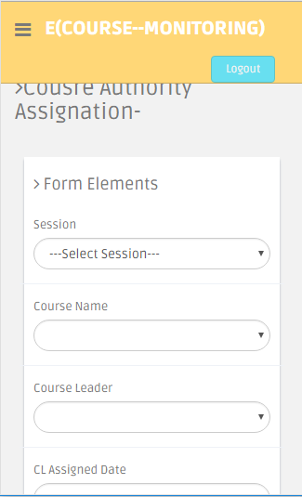

**Fig F.9.1:** Assign new course authority pagemobile view of the system.

**Course Session Assign Page**

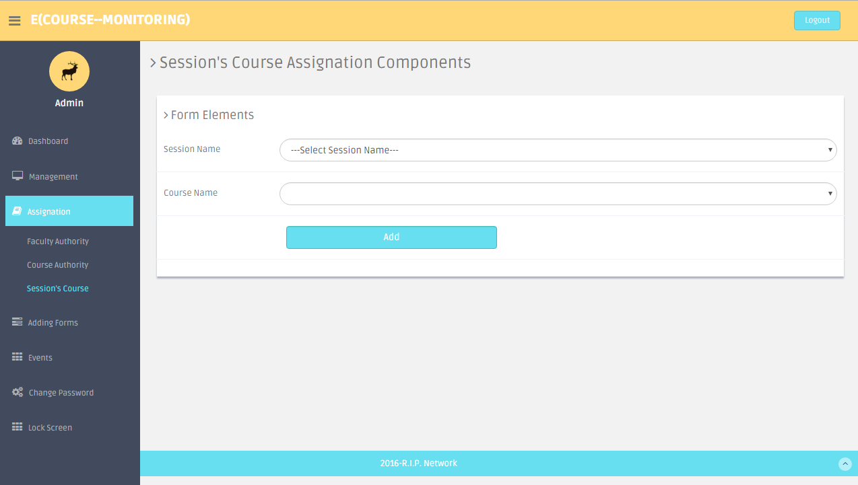

**Fig F.10:** Assign new course session page desktop view of the system.

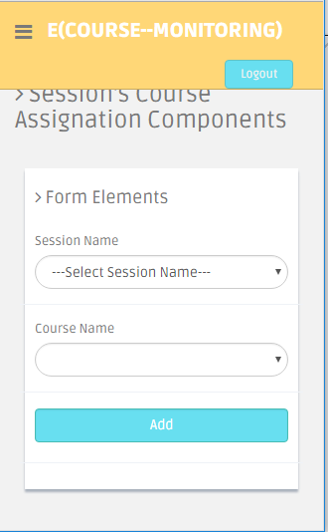

**Fig F.10.1:** Assign new course session page mobile view of the system.

**Add Faculty Page**

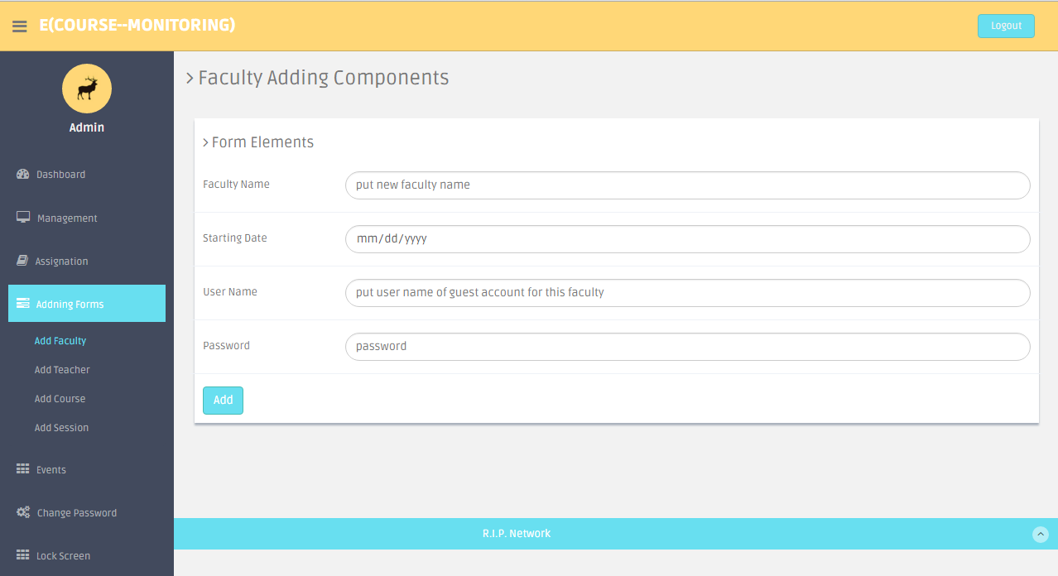

**Fig F.11:** Add new faculty page desktop view of the system.

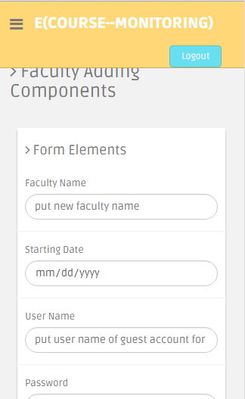

**Fig F.11.1:** Add new faculty page mobile view of the system.

**Add Teacher Page**

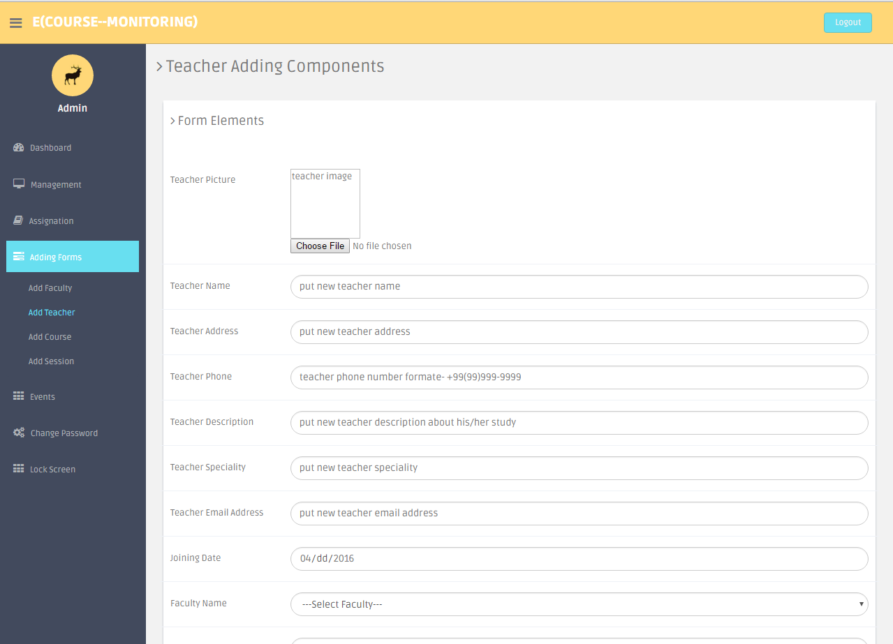

**Fig F.12:** Add new teacher page desktop view of the system.

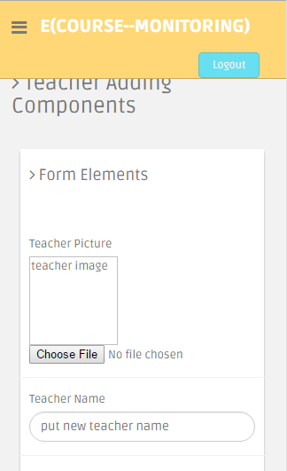

**Fig F.12.1:** Add new teacher page mobile view of the system.

**Add Course Page**

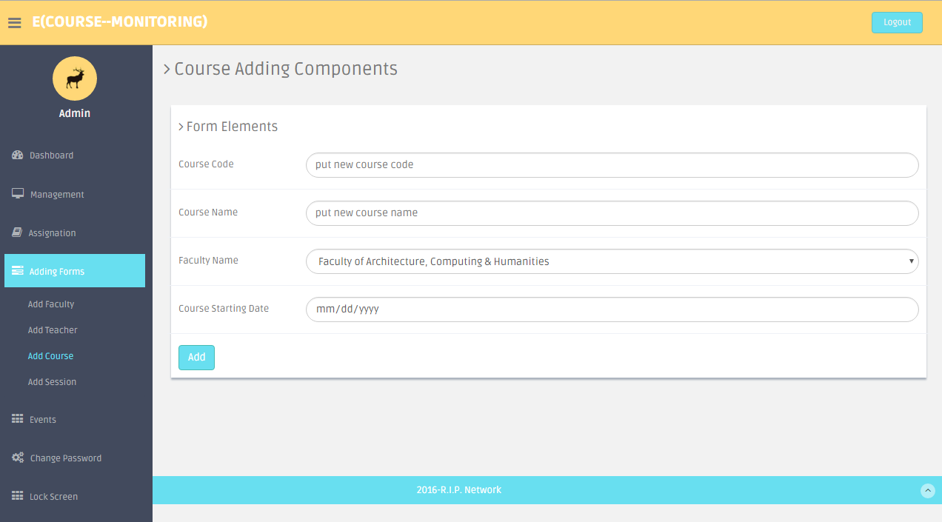

**Fig F.13:** Add new course page desktop view of the system.

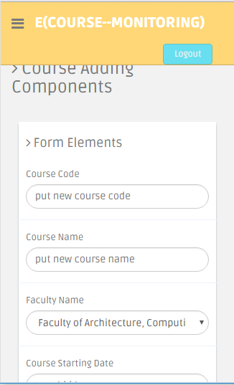

**Fig F.13.1:** Add new course page mobile view of the system.

**Add Session Page**

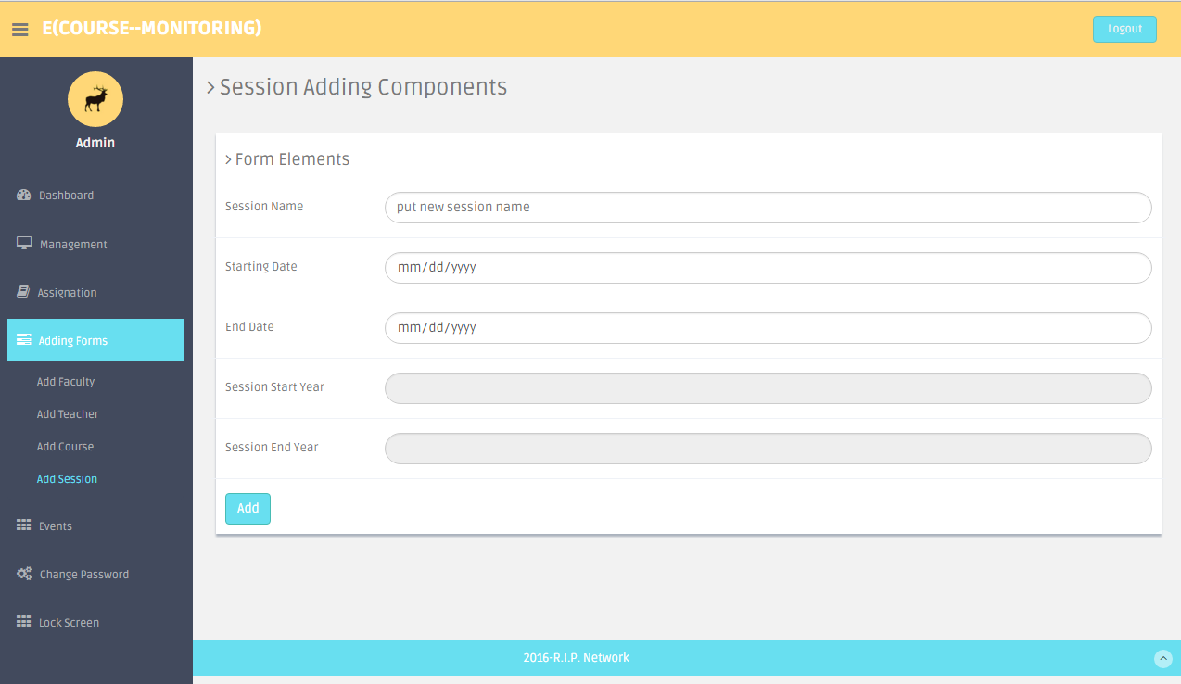

**Fig F.14:** Add new session page desktop view of the system.

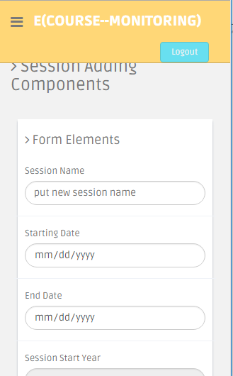

**Fig F.14.1:** Add new session page mobile view of the system.

**Add Event Page**

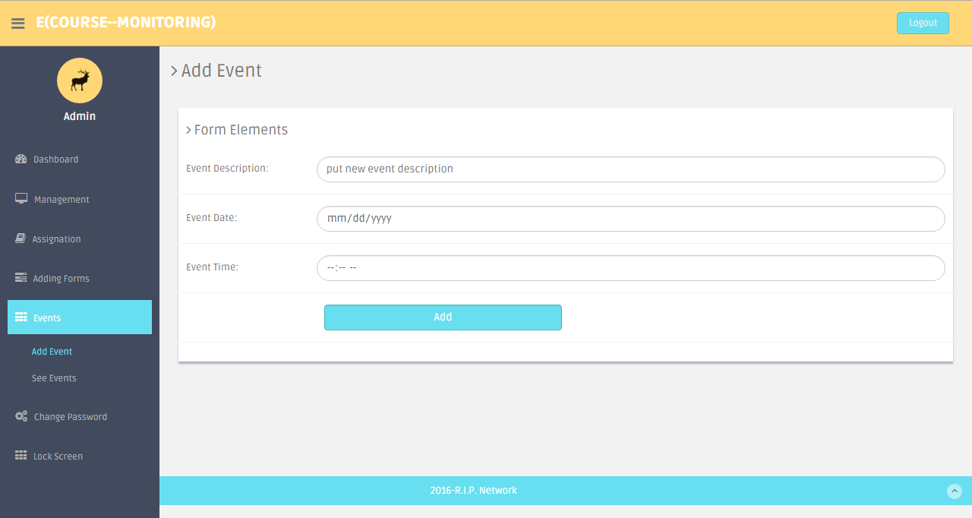

**Fig F.15:** Add new event page desktop view of the system.

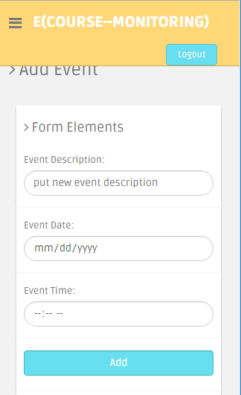

**Fig F.15.1:** Add new event page mobile view of the system.

**See Event Page**

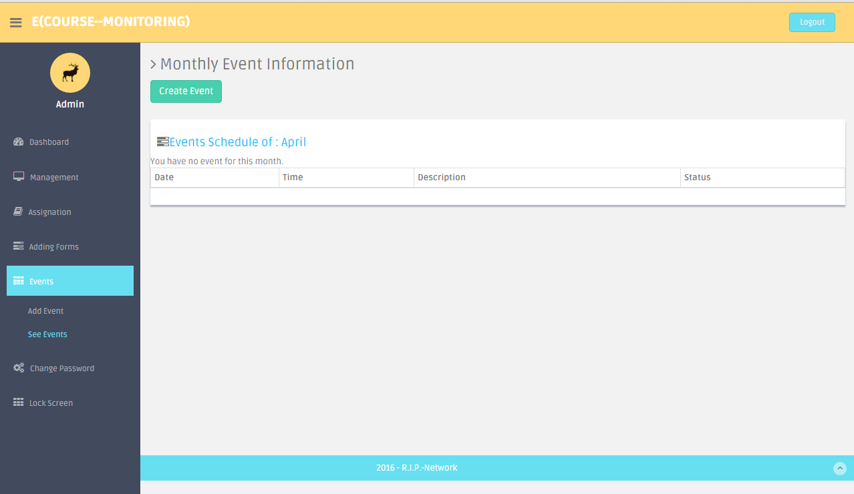

**Fig F.16:** See all event in month page desktop view of the system.

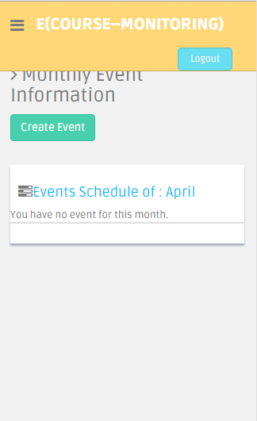

**Fig F.16.1:** See all event in month page mobile view of the system.

**Change Password Page**

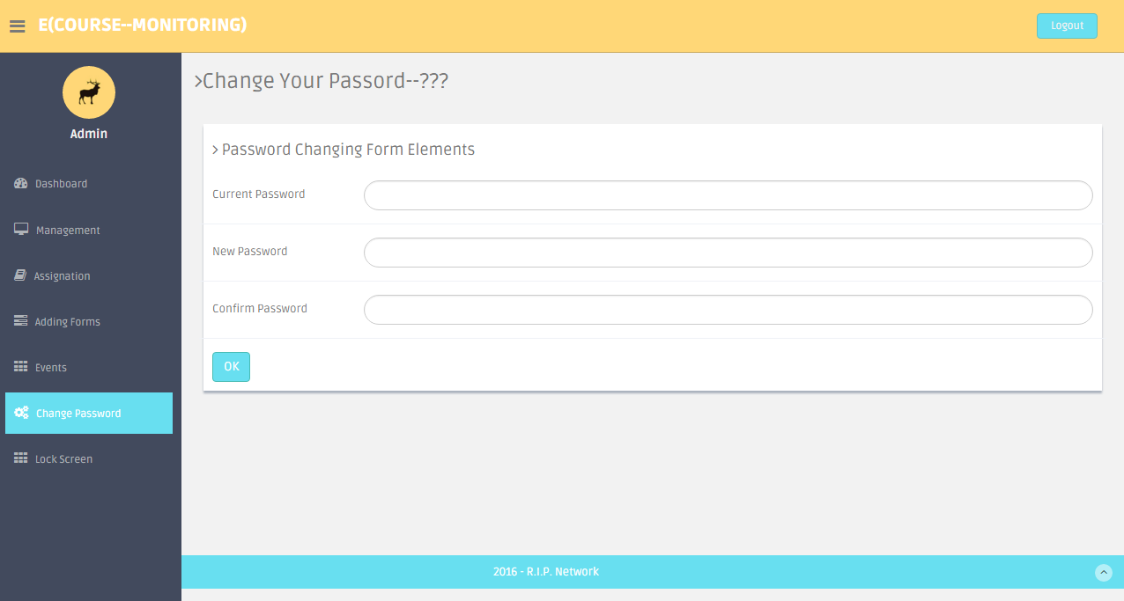

**Fig F.17:** Change password page desktop view of the system.

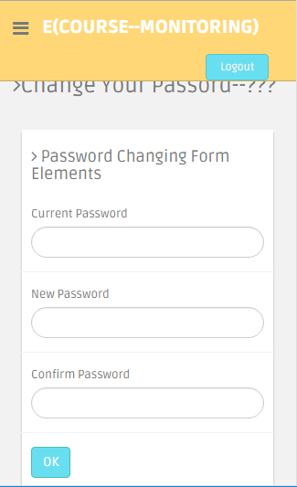

**Fig F.17.1:** Change password page mobile view of the system.

**Lock screen Page**

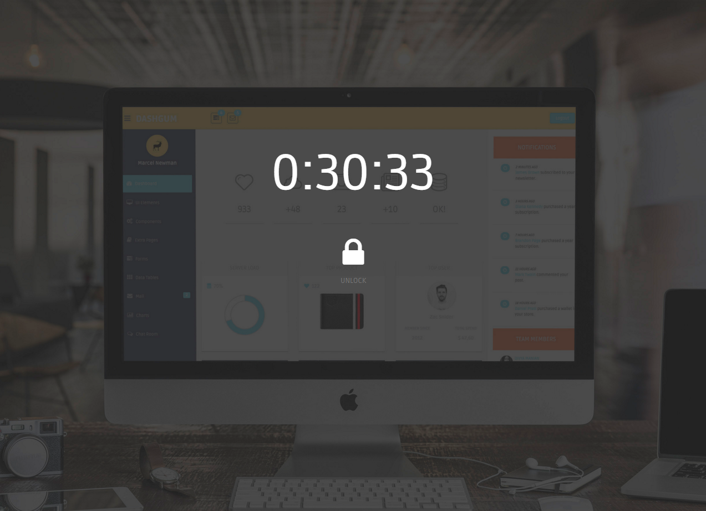

**Fig F.18:** Lock Screen page desktop view of the system.

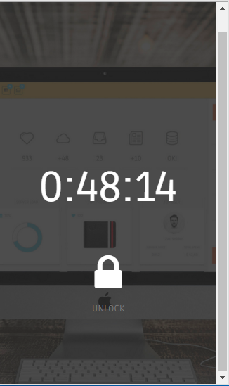

**Fig F.18.1:** Lock Screen page mobile view of the system.

**Admin Profile Page**

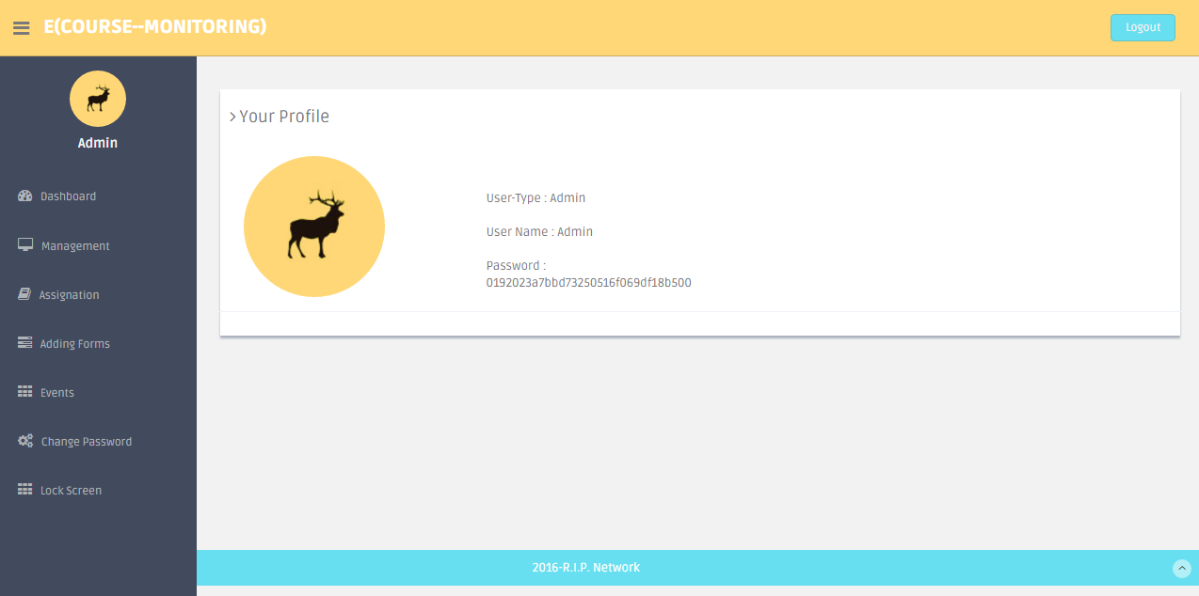

**Fig F.19:** Admin profile page desktop view of the system.

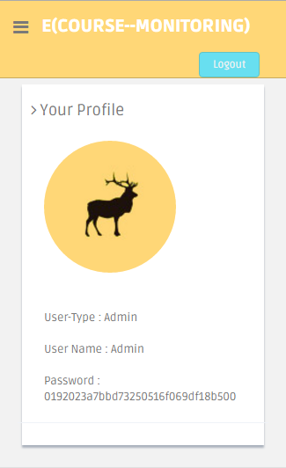

**Fig F.19.1:** Admin profile page mobile view of the system.

**Teacher Dashboard Page**

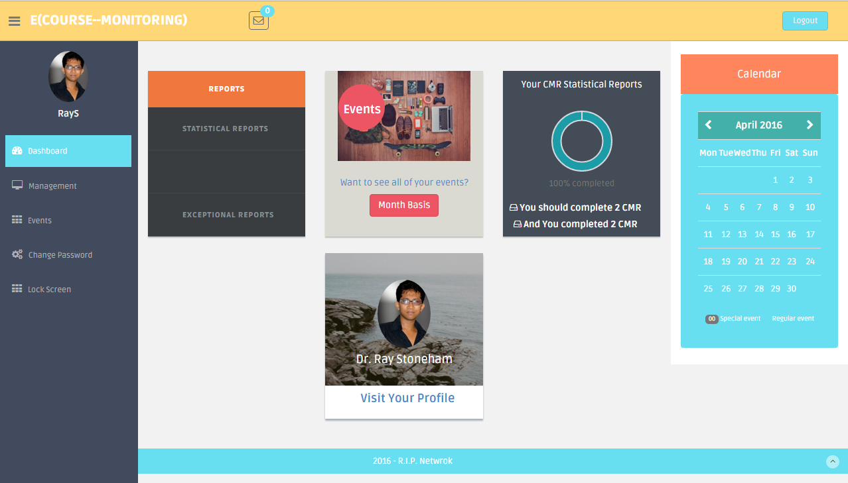

**Fig F.20:** Teacher dashboard page desktop view of the system.

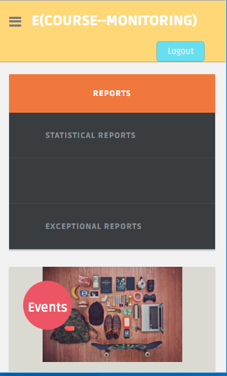

**Fig F.20.1:** Teacher dashboard page mobile view of the system.

**Course moderator list Page**

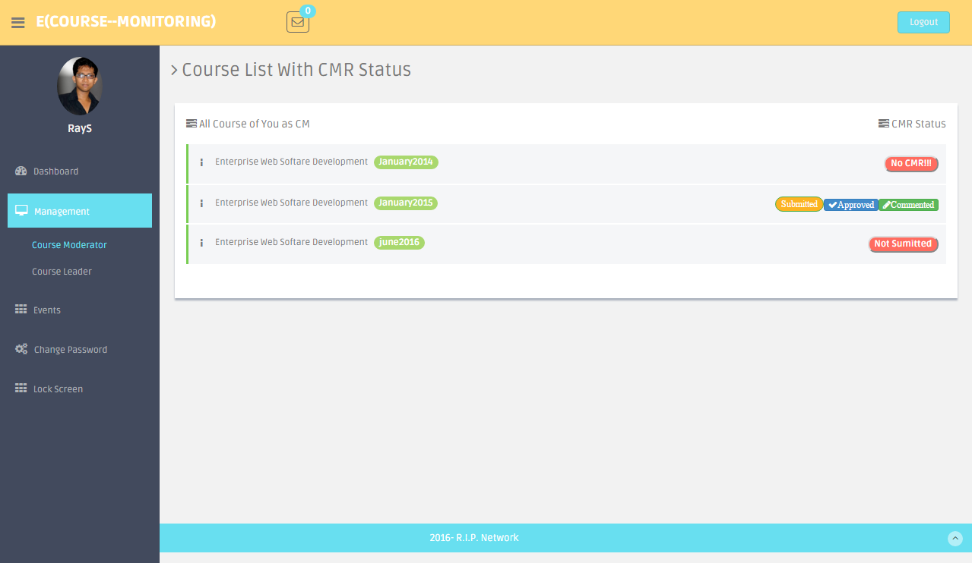

**Fig F.21:** Course Moderator list page desktop view of the system.

**Course Leader List Page**

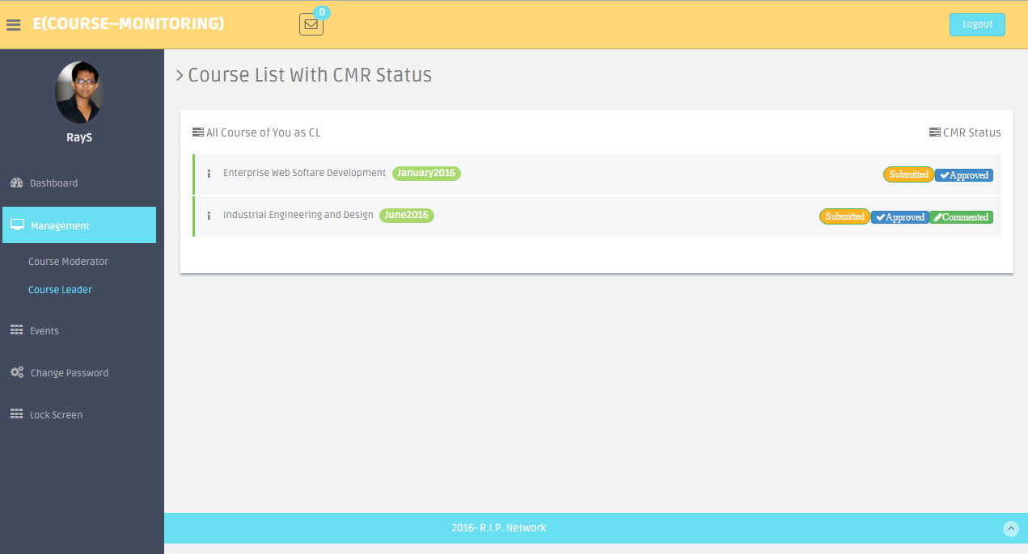

**Fig F.22:** Course Leader list page desktop view of the system.

**Add event(Teacher) Page**

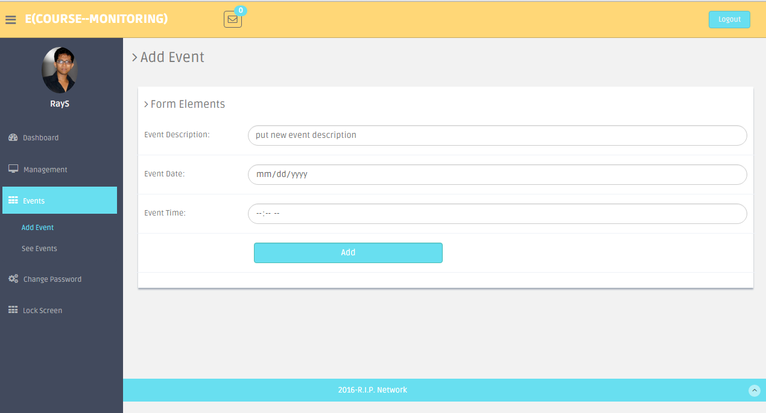

**Fig F.23:** Add event as teacher page desktop view of the system.

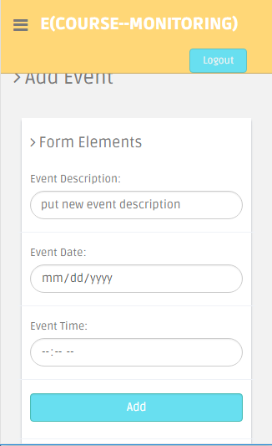

**Fig F.23.1:** Add event as teacher page mobile view of the system.

**See event (Teacher) Page**

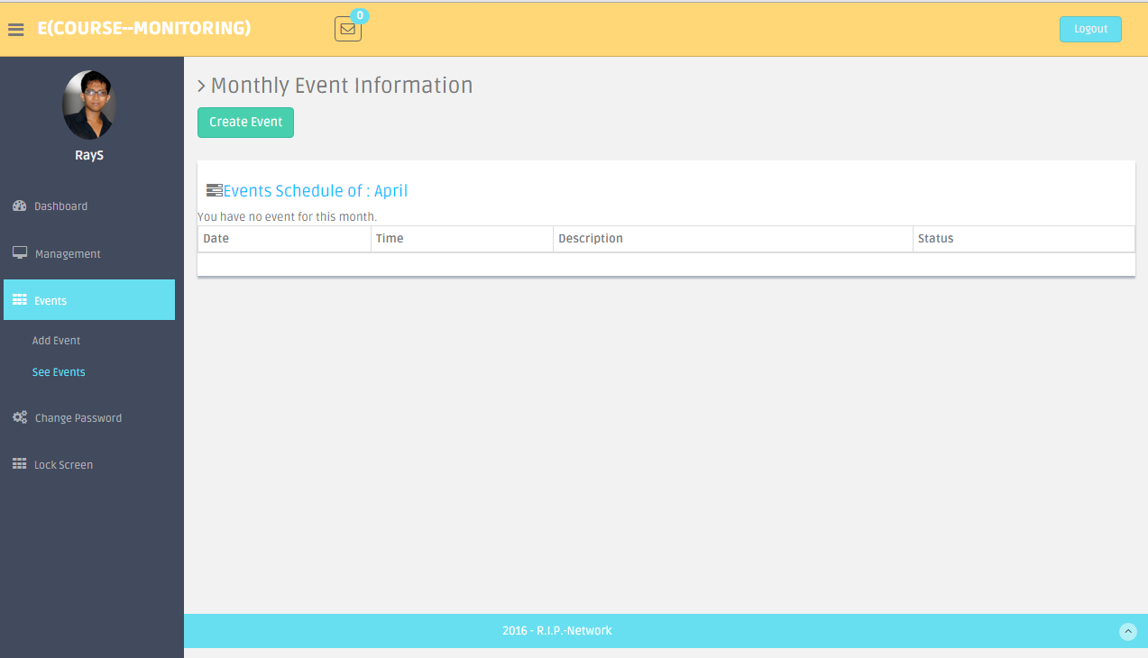

**Fig F.24:** See event list as teacher page desktop view of the system.

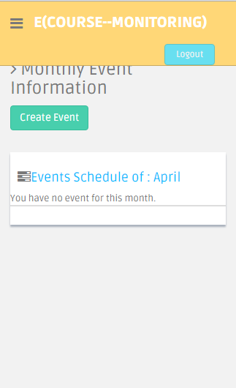

**Fig F.24.1:** See event list as teacher page desktop view of the system.

**Teacher Profile Page**

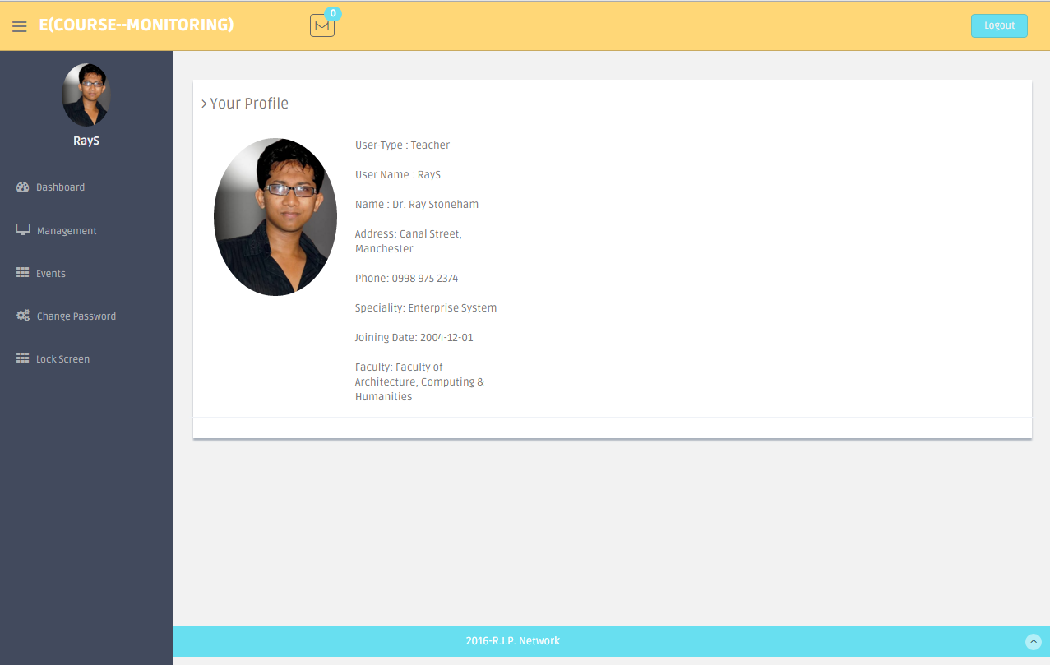

**Fig F.25:** Teacher profile page desktop view of the system.

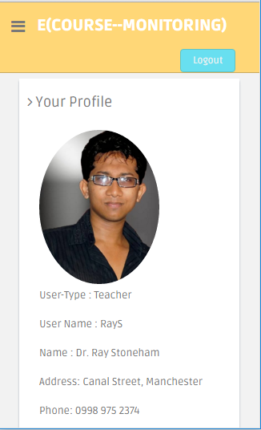

**Fig F.25.1:** Teacher profile page mobile view of the system.

**Guest Dashboard Page**

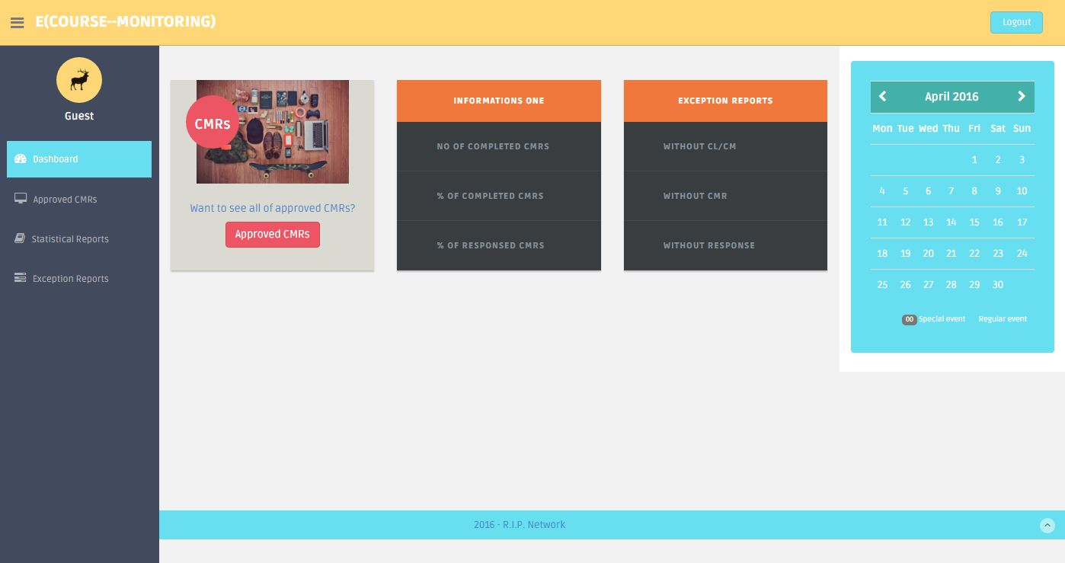

**Fig F.26:** Guest Dashboard page desktop view of the system.

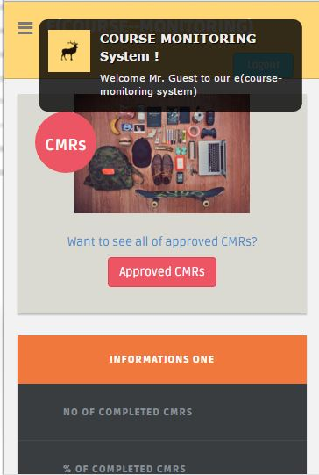

**Fig F.26.1:** Guest Dashboard page mobile view of the system.

**Approved CMR Page for faculties**

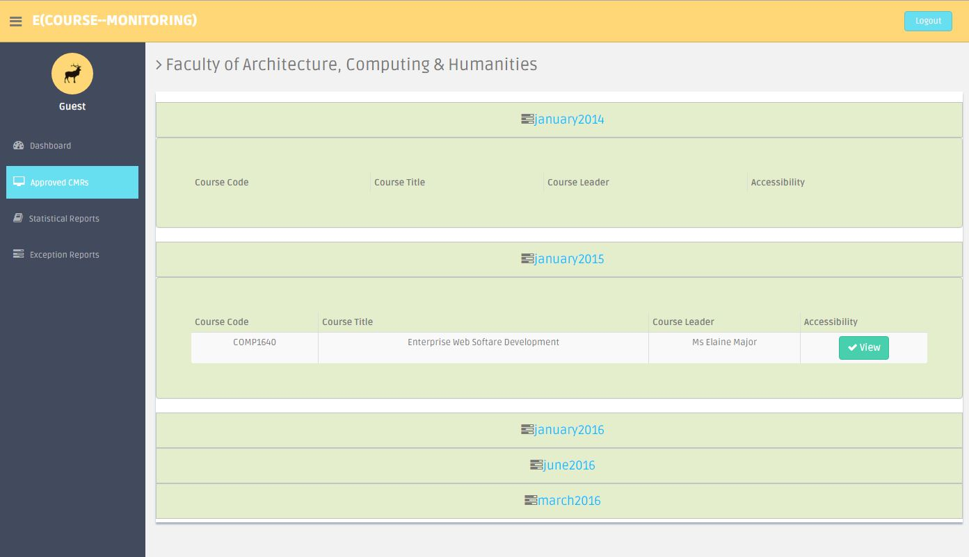

**Fig F.27:** Approved CMR page for faculties desktop view of the system.

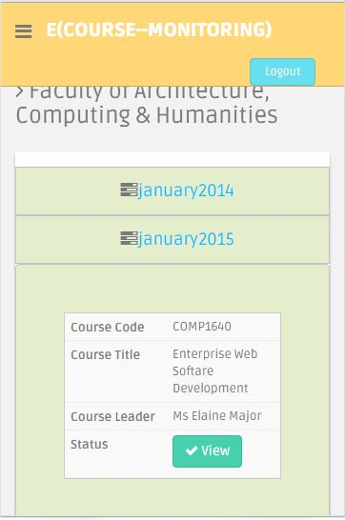

**Fig F.27.1:** Approved CMR page for faculties mobile view of the system.

**All Statistical Reports Page**

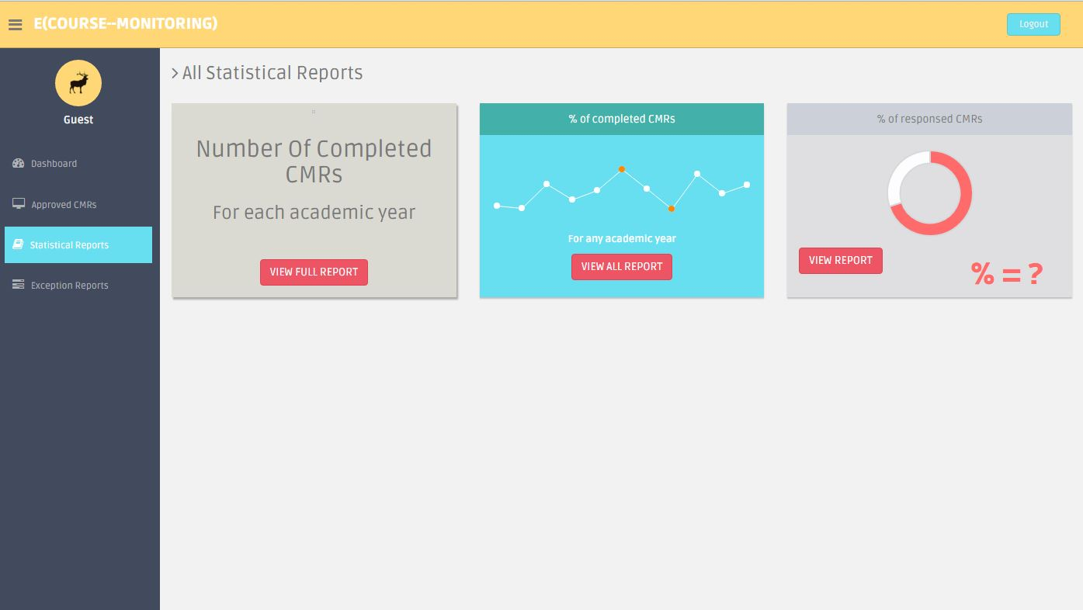

**Fig F.28:** All statistical reports desktop view of the system.

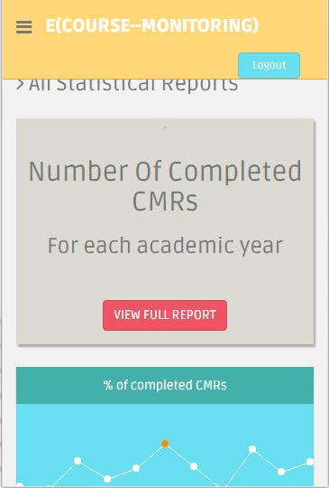

**Fig F.28.1:** All statistical reports mobile view of the system.

**Number of Completed CMR Page**

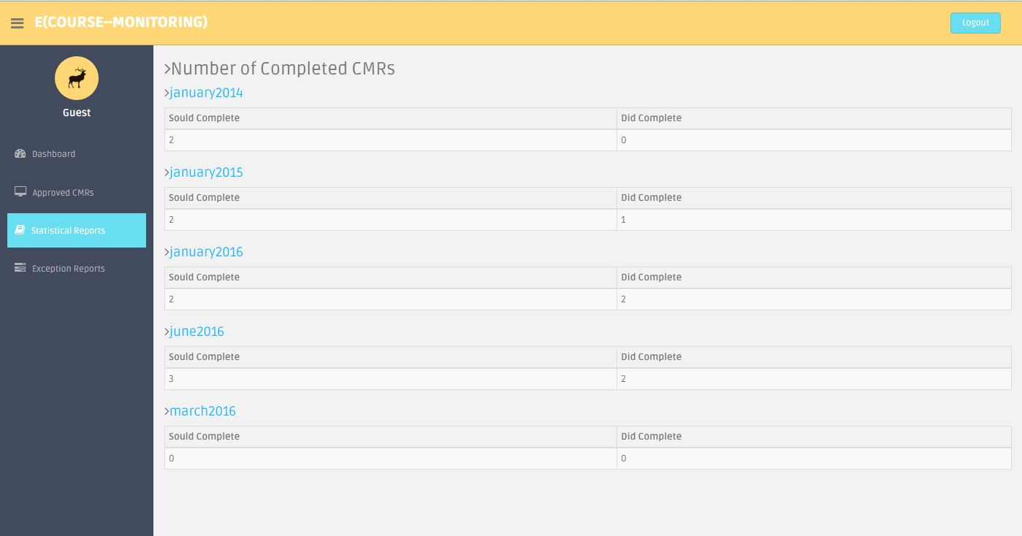

**Fig F.29:** Number of completed CMR page desktop view of the system.

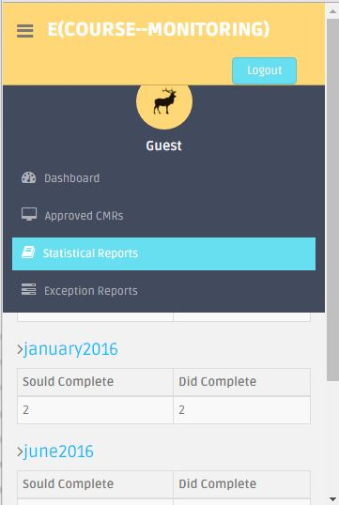

**Fig F.29.1:** Number of completed CMR page mobile view of the system.

**Percentage of completed CMR Page**

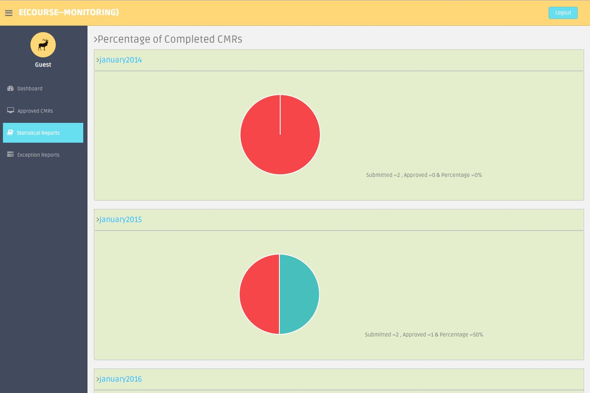

**Fig F.30:** Percentage of completed CMR page desktop view of the system.

**Percentage of responses CMR Page**

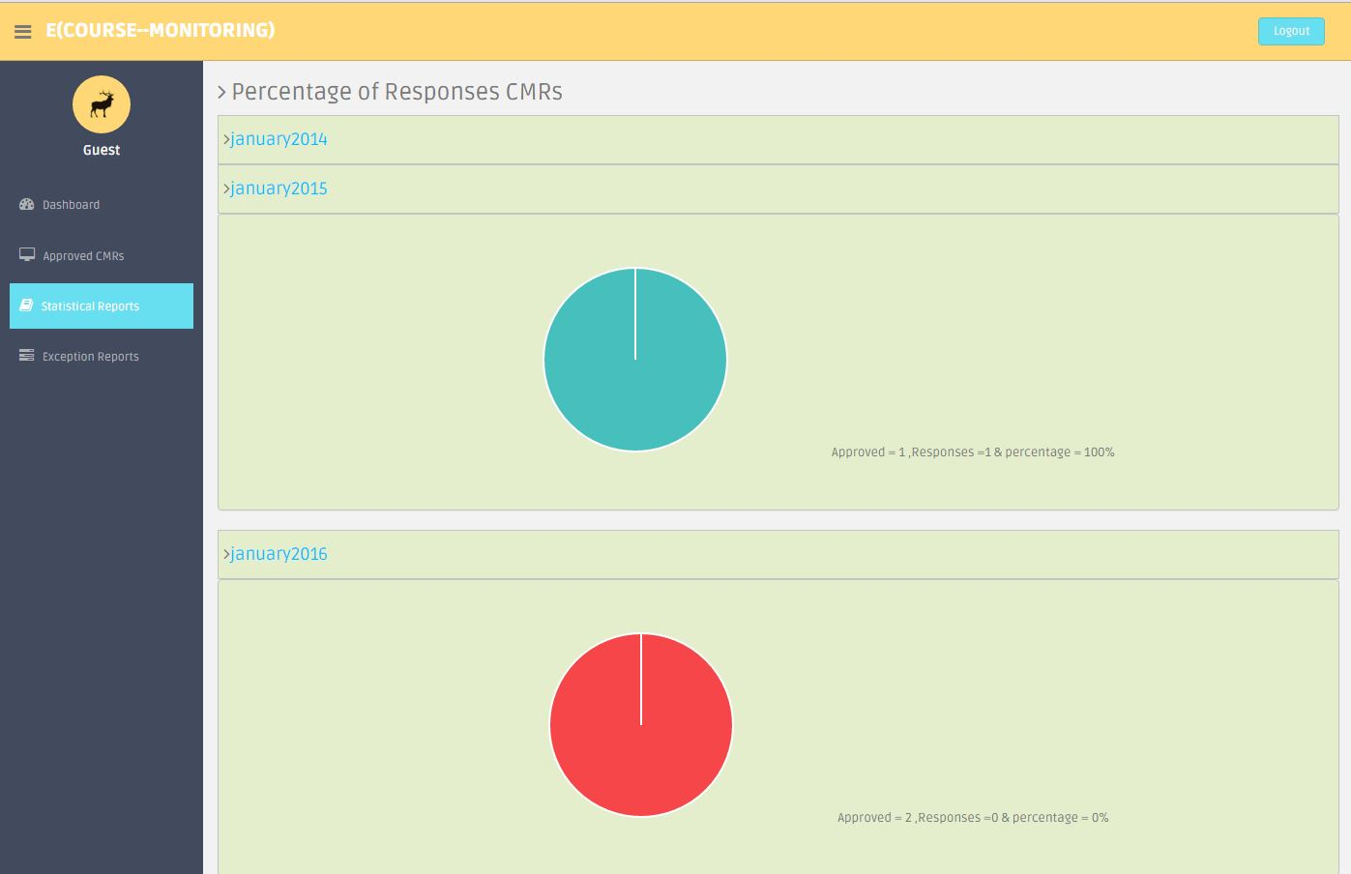

**Fig F.31:** Percentage of responses CMR page desktop view of the system.

**Exception report without CL/CM Page**

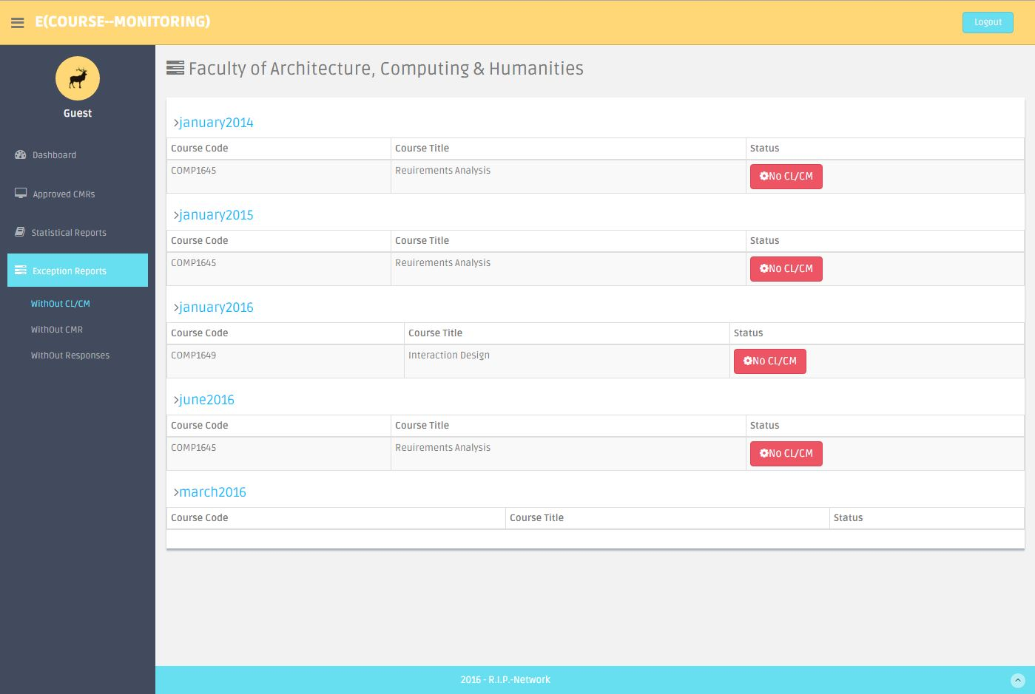

**Fig F.32:** Exception report without CL/CM page desktop view of the system.

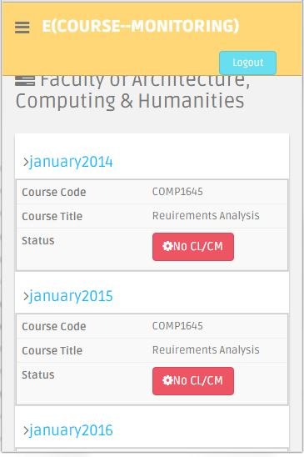

**Fig F.32.1:** Exception report without CL/CM page mobile view of the system.

**Exception report without CMr Page**

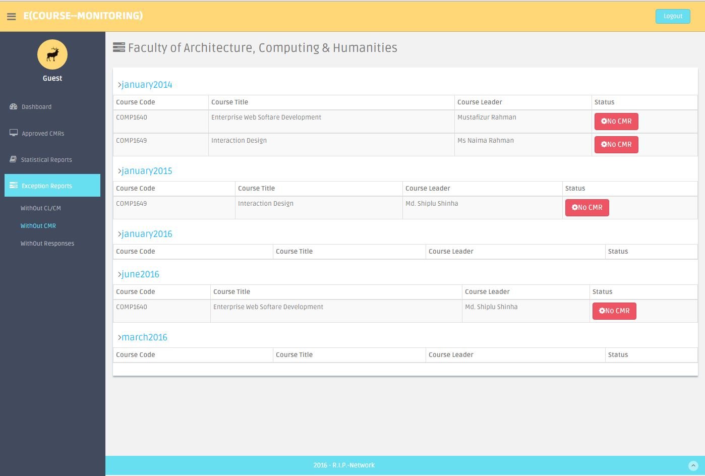

**Fig F.33:** Exception report without CMR page desktop view of the system.

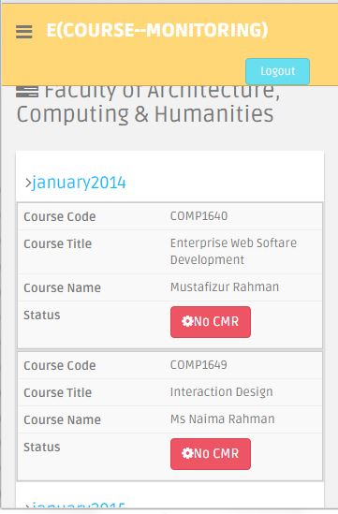

**Fig F.33.1:** Exception report without CMR page mobile view of the system.

**Exception report without responses Page**

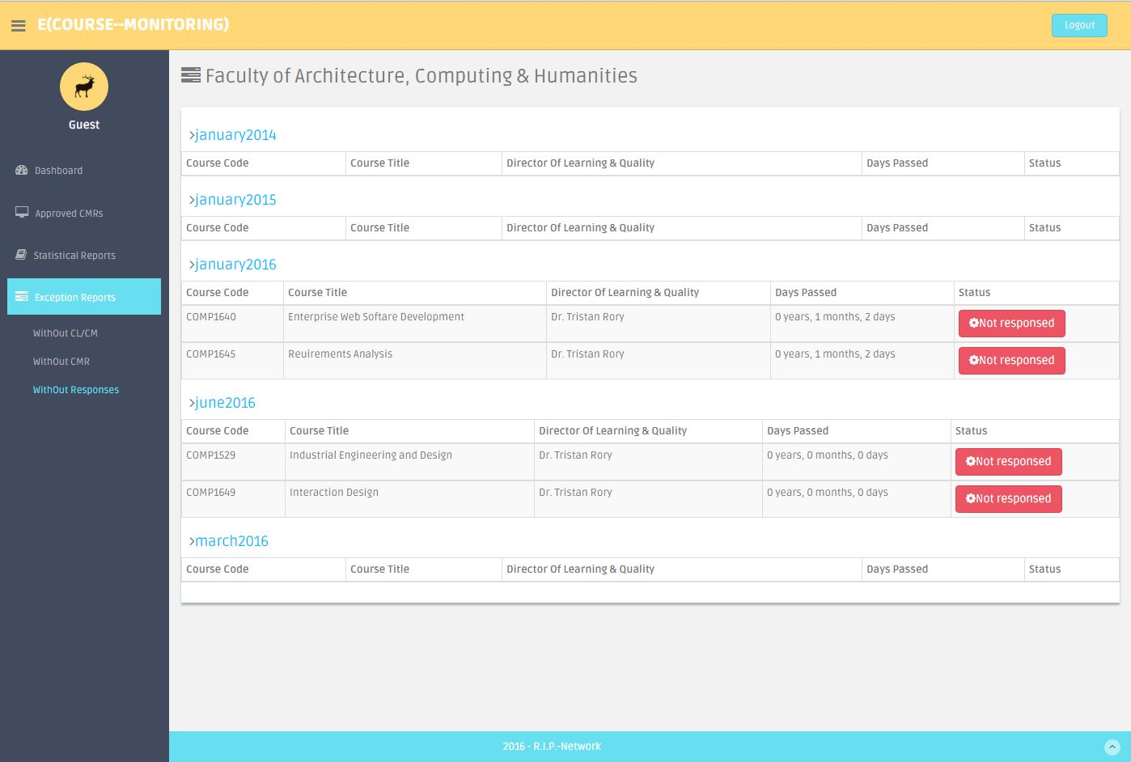

**Fig F.34:** Exception report without responses page desktop view of the system.

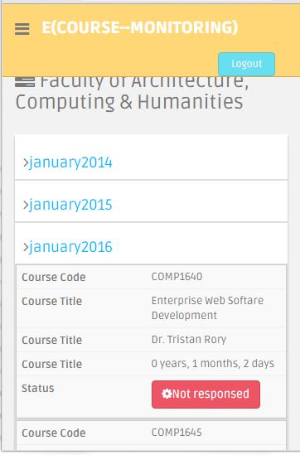

**Fig F.34.1:** Exception report without responses page mobile view of the system.

**Teacher Statistical report showing Page**

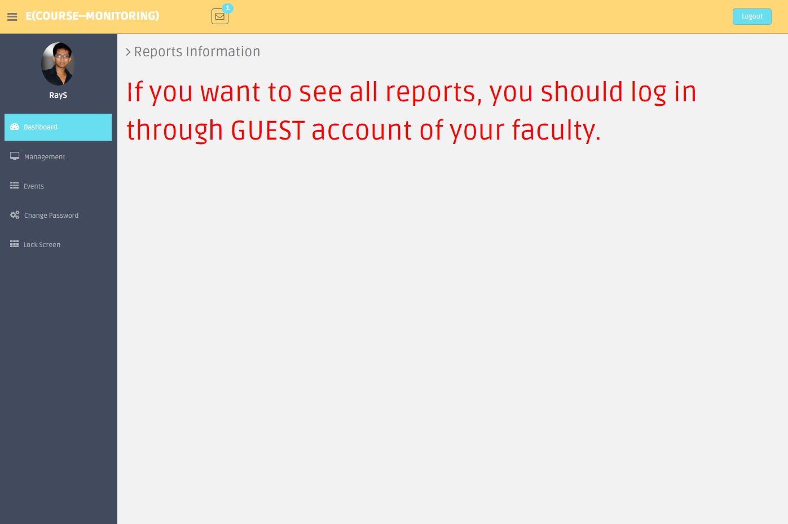

**Fig F.35:** After click statistical report showing page desktop view of the system.

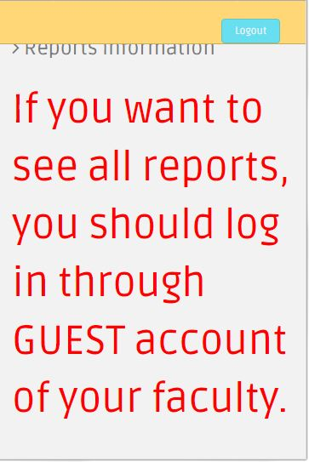

**Fig F.35.1:** After click statistical report showing page mobile view of the system.

**Teacher CMR report Page**

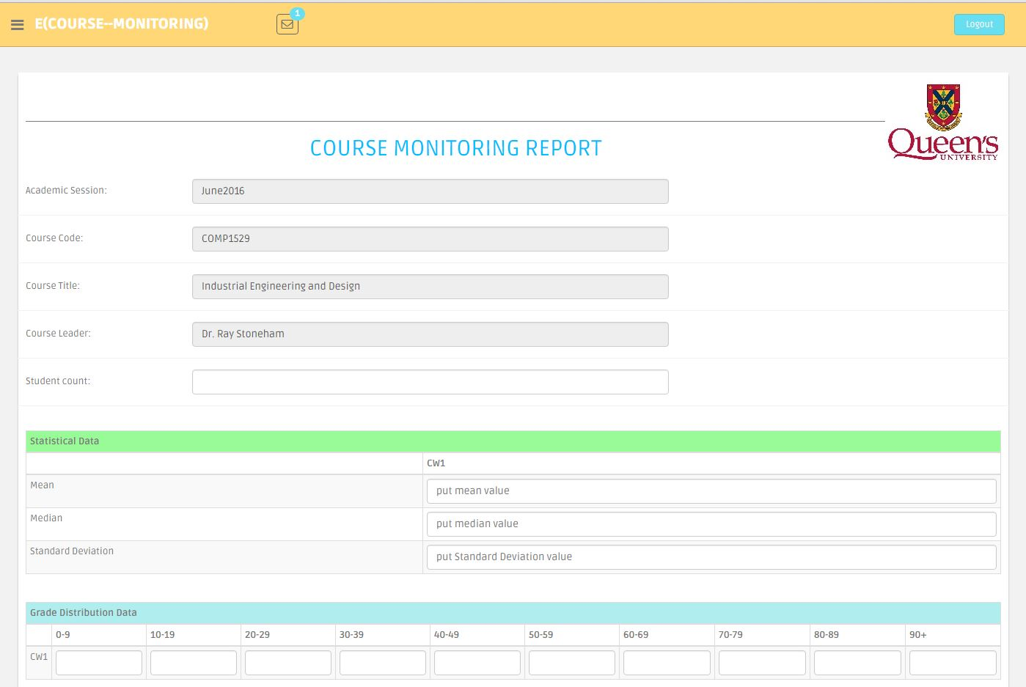

**Fig F.36:** CMR report upper part of page desktop view of the system.

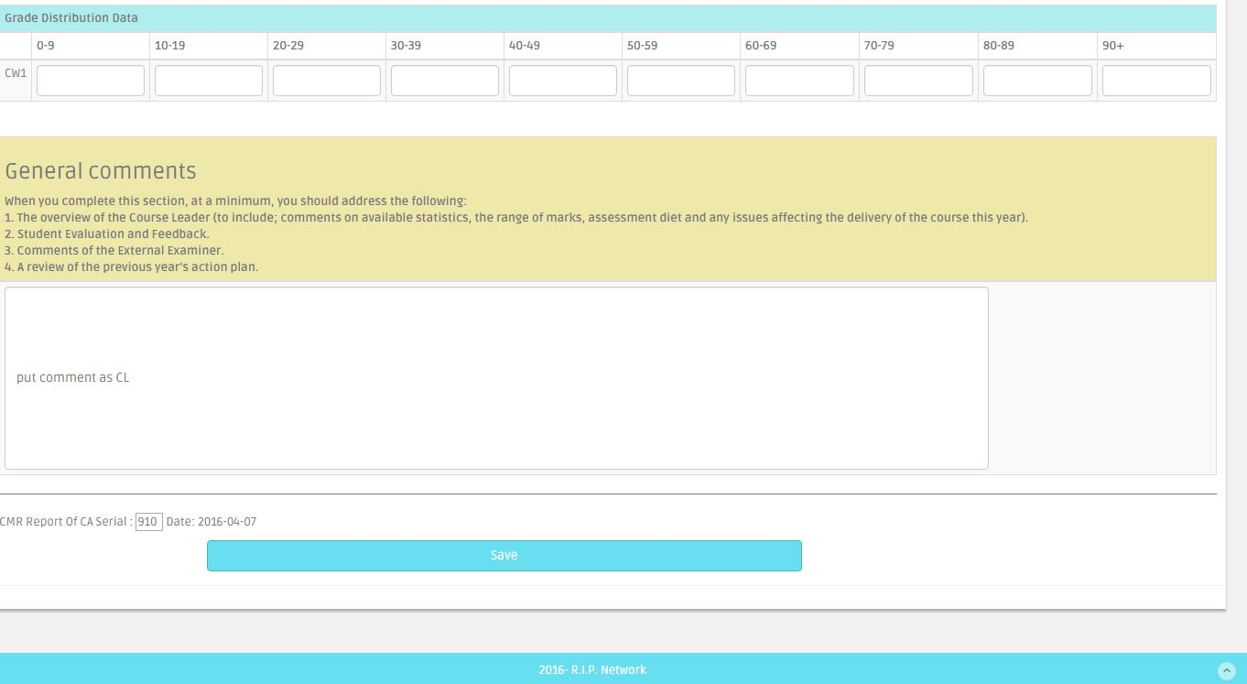

**Fig F.36.1:** CMR report lower part of page desktop view of the system.

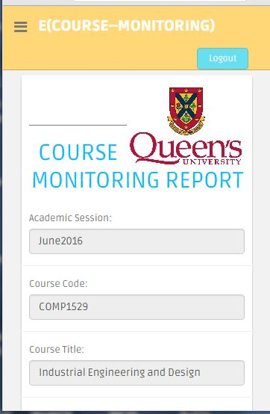

**Fig F.36.1:** CMR report page mobile view of the system.